


Corporate Plan

2025–29
nacc.gov.au
Further information
Enquiries about this report should be directed to the National Anti-Corruption Commission.
Phone: 1300 489 844
Website: nacc.gov.au
Post: GPO Box 605, Canberra ACT 2601
Address: 5 Constitution Avenue, Canberra ACT 2601
Copyright
© Commonwealth of Australia 2025
The material in this report is licensed under a Creative Commons Attribution — 4.0 international license, with the exception of:
- the Commonwealth Coat of Arms
- the National Anti-Corruption Commission logo
- any third-party material
- any material protected by a trademark
- any images and/or photographs.
More information on this CC BY license is set out as follows:
- Creative Commons website
- Attribution 4.0 international (CC by 4.0).
Attribution
The CC BY licence is a standard form licence agreement that allows you to copy and redistribute the material in any medium or format, as well as remix, transform and build upon the material.
This is on the condition that you provide a link to the licence, you indicate if changes were made and you attribute the material as follows:
National Anti-Corruption Commission
Corporate Plan 2025–29
Licensed from the Commonwealth of Australia under a Creative Commons Attribution 4.0 International licence.
ISSN: 2982-1282 (Online)
ISSN: 2982-1274 (Print)
Using the Commonwealth Coat of Arms
Guidelines for using the Commonwealth Coat of Arms are available from the Department of the Prime Minister and Cabinet website.

In the spirit of reconciliation, the National Anti‑Corruption Commission acknowledges the Traditional Custodians of Country throughout Australia and their connections to land, sea and community. We pay our respect to their Elders past and present and extend that respect to all Aboriginal and Torres Strait Islander peoples today.
This artwork tells the story of the National Anti‑Corruption Commission’s mission to enhance integrity within the Commonwealth public sector.
It is made up of many multicoloured strokes, depicting our team’s many weaving histories. At the core of the artwork are three white patterned rings, representing detecting, deterring, and preventing corruption. Our approach is fearless but fair and we work towards our goals with integrity, determination, and courage. We are on a journey to build a culture of unity, inclusion, and trust as we grow.
Our people working together are represented by white dots between each of the lines. At the heart of the artwork is the central element, encapsulating our commitment to contributing to reconciliation as we work to create a culturally safe environment where First Nations staff and partners feel respected and included.
Integrity at Our Heart
The artwork concept and narrative were developed by Navada Currie. Navada is a Mununjali and Kabi Kabi artist at Gilimbaa.
Contents
Commissioner’s foreword 6
Introduction 12
Purpose 14
Key activities 18
Detecting corruption 19
Receiving and assessing referrals 19
Conducting investigations 21
Referring corruption issues to other Commonwealth agencies for investigation 22
Creating and disseminating corruption prevention information and education 23
Operating context 25
Operating environment 25
Capability 33
Risk oversight and management 36
Performance 42

Commissioner’s foreword

The Hon Paul Brereton AM RFD SC
National Anti-Corruption Commissioner
The National Anti‑Corruption Commission’s Corporate Plan for 2025–29 describes the organisation’s outlook and strategic direction for the next 4 years.
The Commission was established to provide independent assurance to the Australian community that corrupt conduct involving Commonwealth public officials is prevented, detected, investigated, and responded to appropriately.
Our mission is to enhance integrity in the Commonwealth public sector by deterring, detecting and preventing corrupt conduct involving Commonwealth public officials, through education, monitoring, investigation, reporting and referral.
Integrity in the Commonwealth public sector is critical to ensuring that public power is exercised honestly, impartially and in the public interest. It is also essential to ensuring that programs that are intended to deliver benefits to the people do so, and are not eroded by the diversion of resources along the way for improper purposes.
In the 2 years since our commencement on 1 July 2023, we have had 2 main lines of operation to achieve our mission, and these will continue to be our focus:
- deterring corrupt conduct through detection, investigation and exposure
- preventing corrupt conduct through education and engagement.
We will continue to invest in the development and welfare of our people, which has grown to over 230 expert and committed staff, in 5 offices across the nation, including 3 which have been fitted out and occupied since we opened our doors.
The Commission’s remit and public understanding
The Commission is committed to improving understanding not only of outcomes achieved, so as to provide assurance that corrupt conduct is being detected and deterred, but also of our remit and processes, including building greater awareness of what we can and cannot do, how we decide what we will investigate, and why most referrals to us are not investigated.
There are multiple Commonwealth agencies which have the function of ensuring, in different ways, that public authorities exercise the powers conferred on them properly, and in sustaining confidence in the institutions of government by showing, through their existence and actions, that exercises of public power and performance of public functions are subject to independent and objective scrutiny in order to ensure that they are proper. These guardrail institutions include the Auditor‑General, the Commonwealth Ombudsman, the Australian Information Commissioner, the Australian Public Service Commissioner – and now, the National Anti‑Corruption Commission, the newest and youngest of them.
The distinction of the Commission is that its jurisdiction is concerned with serious and systemic corrupt conduct in the Commonwealth public sector. Most mistakes, maladministration and misconduct do not involve corrupt conduct and are not within the jurisdiction of the Commission. Other agencies have responsibility for oversight of administration decision making, the efficient and effective use of resources, and other aspects of the exercise of public power. The Commission is not a complaints‑handling agency nor an administrative decisions review authority.
However, Australians are entitled to expect that public officials perform their functions honestly and impartially, that they exercise the powers conferred on them for the public purposes for which those powers were conferred, and for no other purpose; and that they not use their public position for private advantage. These are the core values with which the Commission is concerned: to provide assurance to the people that public power, position and privilege is exercised in the public interest and not for private or other improper purposes or benefit.
Anyone can refer a question of whether there has been corrupt conduct involving a public official to us. That does not mean that we will investigate every matter that is referred to us. In deciding whether and if so how to deal with a referral, the Commission considers the seriousness and scale of the conduct described, whether there is a realistic prospect of finding corrupt conduct, whether there have been other investigations of it, whether it is preferable that another agency investigate it, and whether and to what extent a corruption investigation by the Commission is likely to add value in the public interest.
Detecting, investigating and exposing corrupt conduct
Our main effort will remain detection, investigation and exposure of corrupt conduct.
Our 6 strategic corruption priorities remain corruption in senior executive decision‑making, corruption involving contractors and consultants, corruption affecting vulnerable people, corruption affecting the environment, corruption at the border, and corruption in complex procurement. But while it is in these areas that we believe that we can generally best add value, they are not exclusive.
The Commission is conscious that some have called for greater speed in delivering outcomes and greater publicity of our investigations. The detection, investigation and exposure of corrupt conduct is necessarily challenging. Corruption is generally conducted in secret, often involving complex pathways of deception and deceit. Finding, testing, challenging and unravelling these pathways takes time. Getting the right and fair outcome also takes time.
Firstly, it usually takes some time to decide whether the Commission should investigate a referral, because this is a significant decision as to how we will allocate our resources. Secondly, commencing an investigation is a significant decision for the Commission given our limited resources. Many of the Commission’s powers appropriately require warrants and notices to produce to be obtained and this too takes time. Often the result of those warrants or notices to produce is the acquisition of very large volumes of information that require significant time and resources to analyse and decipher. Sometimes, questions of legal professional privilege or parliamentary privilege have to be resolved before documents can be made available to investigators. Drafting reports, including fair and careful consideration of whether to make a finding of corrupt conduct and any corruption prevention observations and recommendations is an exacting process. Time is also required to arrange and conduct the hearings that may follow. Procedural fairness to affected persons protracts this. This is similar for other anti‑corruption commissions around the country, and the Commission's performance measure remains finalising 60% of investigations within 2 years.
The legislation that governs the Commission provides that only in exceptional circumstances will the Commission conduct public hearings. This is chiefly to avoid the risk of unfair and premature damage to reputations that can be caused when unproven allegations of corruption are publicised, and to avoid compromising the efficacy and fairness of investigations that might be compromised if people know they are under investigation. In addition, it is our experience that witnesses are usually more willing to be open and frank in a private setting. We also have to be conscious of the impact of our investigations on individuals with whom we interact.
Education and engagement
Two years is a very short time in the life of a national institution, and enhancing integrity across the Commonwealth public sector is a long‑term endeavour. Integrity is not a permanent state one can expect to reach. Integrity is a practice, supported by education, frameworks and systems, that one continually seeks to enact.
The existence and work of the Commission to date has laid a strong foundation for the enduring enhancement of integrity. One manifestation of this is that in the 2 years since our inception, integrity has been at the forefront of discourse throughout the Commonwealth public sector. Never before has there been such a focus on integrity: everyone is talking about it; and most are conscious of our existence and remit. While this is by no means attributable only to the Commission, the establishment, existence and educational activities of the Commission have contributed in a substantial measure.
As I stated at the opening of the Commission, we cannot achieve our mission alone. Over the last 2 years we have established strong relationships with our state and territory counterparts, and other Commonwealth integrity agencies. From these we, as a young agency, gain significant benefits through the exchange of knowledge and best practices.
While prevention work is often overshadowed by detection and investigation, education is the key to cementing system‑wide integrity awareness and hardening our institutions against key corruption risks and vulnerabilities. The Commission will continue to conduct targeted corruption prevention engagement and education, focussed on our jurisdictional agencies, on contractors and consultants, and on the public, to build resistance to corrupt conduct, to encourage people to report it, and to create a culture in which corruption is not tolerated.
Looking ahead
As the Commission enters its next phase, complex investigations will reach completion and the Commission’s operational achievements will gradually become more visible. Inevitably, much of our investigation work will lead to findings that a corruption issue is not sustained, and that does not matter – corruption in the Commonwealth public sector is very much the exception and not the norm, and our ability to dispel suggestions that there has been corrupt conduct is as important as exposing it where it exists. However, some of that work, protracted and painstaking as it is, will result in the exposure of serious and systemic corrupt conduct. Both outcomes serve, in slightly different ways, to enhance integrity and sustain confidence in the institutions of government, by showing that exercises of public power and performance of public functions are subject to independent and objective scrutiny, in order to ensure that they are proper.

The Hon Paul Brereton AM RFD SC
National Anti-Corruption Commissioner

Introduction

Mr Philip Reed
Chief Executive Officer
As the Chief Executive Officer and Accountable Authority of the National Anti‑Corruption Commission, I am pleased to present the Commission’s 2025‑29 Corporate Plan as required under section 35(1)(b) of the Public Governance, Performance and Accountability Act 2013 (PGPA Act).
This plan is prepared for the financial year 2025–26 and covers the 4-year period 2025–29.
The plan identifies the purpose, including guiding principles, key activities, operating context and performance measures for the Commission for the next 4 years. It details the opportunities and challenges we face and how we will measure and assess the Commission’s performance in achieving its purpose.
The reporting period will be a significant phase for the Commission as we further expand our workforce and capability, and shift from key establishment activities to executing our core functions in line with our performance measures. Our focus will be on delivering on our priorities effectively, embedding systems to support continual improvement, and remaining responsive in an ever-changing operating environment.

Mr Philip Reed
Chief Executive Officer

Purpose
The National Anti‑Corruption Commission is an independent Commonwealth entity established under the National Anti‑Corruption Commission Act 2022 (NACC Act) to provide independent assurance to the Australian community that corrupt conduct involving Commonwealth public officials is prevented, detected, investigated and responded to appropriately.
The Commission’s mission is to enhance integrity in the Commonwealth public sector by deterring, detecting and preventing corrupt conduct involving Commonwealth public officials through education, monitoring, investigation, reporting and referral.
Under the NACC Act, the Commission can investigate alleged corrupt conduct involving Commonwealth public officials.
Public officials include parliamentarians (including ministers), and staff members of Commonwealth agencies. Staff members of Commonwealth agencies include individuals employed by or engaged in assisting the agency, and individuals responsible for delivering goods or services to or on behalf of the agency under a Commonwealth contract administered by the agency.
Corrupt conduct is:
- conduct by a public official that involves a breach of public trust. This means a public official using a power or discretion for a purpose for which it was not conferred, typically a private purpose
- conduct by a public official that involves an abuse of office. This means a public official using their position to gain a private advantage
- misuse of official information. This means a public official or former public official making improper use of information they obtained in their official capacity
- conduct by anyone, including a public official, to cause a public official to perform their public functions other than honestly or impartially.
The Commission cannot investigate concerns relating to state, territory or local government officials. Each state and territory has a similar integrity or anti-corruption commission that may be able to investigate those matters.
The Commission is not a complaints-handling agency, nor an administrative decisions review authority. Making a referral to the Commission is not like making a referral to the Ombudsman or an application to the Administrative Reviews Tribunal: the Commission does not adjudicate on individual complaints. Referrals to the Commission are not individual initiating processes on which a referrer is entitled to an adjudication, but a source of information that, with other information, can help the Commission identify and decide what it should investigate, and where it should focus in the public interest, to have the optimal impact in deterring and preventing corrupt conduct.
Often that means the Commission will focus on matters which are not and have not been the subject of investigation by other agencies, rather than those which have been or are under investigation elsewhere.
To investigate a corruption issue, the Commission must have information raising the possibility that a person has done or could do something that:
- involves, or could involve, a public official
- is, or could be, corrupt conduct under the NACC Act
- could involve serious or systemic corrupt conduct.
The NACC Act does not define serious or systemic corrupt conduct. Under section 279 of the NACC Act, the Commission has issued guidance on what is serious or systemic corrupt conduct to assist public officials with the operation of the Act, available on the Commission website.
Serious corrupt conduct is corrupt conduct that is significant, more than negligible or trivial, and does not have to be severe or grave.
Systemic corrupt conduct is corrupt conduct that involves more than an isolated case, involves a pattern of behaviour, or affects or is embedded in a system. It can occur in one or multiple agencies, and can involve one or multiple individuals, and does not have to be coordinated.
Guiding principles
Five guiding principles inform how the Commission operates and makes decisions. These are:
- Independent
- Value adding
- Evidence based
- Data driven
- People focused

Independent
The Commission operates independently of government and impartially, to maintain the trust of the Australian public. This means no-one can tell the Commission what to investigate or what to decide.

Value-adding
The Commission focuses on matters where it is best positioned to add value in the public interest by deterring or preventing corruption in circumstances where other agencies are less well-equipped to do so. This means the Commission is less likely to investigate a matter if another agency has already addressed it or is well-equipped to do so.

Evidence-based
The Commission acts on evidence. This means Commission decisions are based on evidence, not on speculation or on populism.
Data driven
The Commission is informed by data. This means the Commission uses data to form insights and identify current trends and emerging risks and issues.

People focused
The Commission cares for people: above all its staff, but also those who engage with it and are affected by its operations. This means the Commission invests in and cares for its workforce to ensure they have the skills, knowledge and capability to succeed.
It also means the Commission endeavours to mitigate the inevitable distress that individuals dealing with or affected by its operations may sometimes experience.

Key activities
To achieve its purpose and execute its mission, the Commission has 2 main lines of operation. These are:
- deterrence through detection, investigation and exposure
- prevention through engagement and education.
These lines of operation are reflected in the Commission's 5 key activities included in the Portfolio Budget Statements 2025-26:
  - detecting corruption and enhancing the Commonwealth public sector’s capabilities to detect corruption
  - receiving and assessing referrals of alleged corrupt
  - conducting investigations into corruption issues that could involve serious or systemic corrupt conduct. These investigations may be undertaken jointly with other Commonwealth agencies or with state or territory agencies
  - referring allegations of corrupt conduct to other Commonwealth agencies for investigation
  - creating and disseminating information and education to enhance the effectiveness and maturity of approaches to corruption prevention and build a strong integrity culture across the public sector.

Detecting corruption
The Commission detects corruption through a variety of methods, including:
- voluntary referrals made through the Commission’s webform, by phone or by post
- mandatory referrals from agency heads who become aware of a corruption issue concerning a staff member of their agency which could involve serious or systemic corrupt conduct
- information received by the Commission in other ways (including media reports)
- strategic intelligence and data analysis by the Commission
- information obtained during a Commission investigation that identifies another corruption issue.
The Commission is developing a monitoring and auditing function to ascertain compliance with mandatory reporting obligations, evaluate the integrity structures and processes of agencies, and identify vulnerabilities and issues related to corruption within these agencies.

Receiving and assessing referrals
The Commission assesses referrals to ascertain whether they are within jurisdiction (that is, they relate to a Commonwealth public official), whether they appear to raise a corruption issue, whether they could involve serious or systemic corrupt conduct, and if so whether and how to deal with them.
The Commission may seek further information in relation to a referral, including from the person who made the referral. The Commission may also conduct a preliminary investigation to obtain more information and determine if there is a corruption issue and how to deal with the issue.
The Commission can decide not to take any action in relation to a referral. The Commission does not have to consider or respond to every referral it receives. However, as a matter of courtesy, the Commission usually provides a response to each person who makes a referral, if they provide contact details.
If a referral raises a corruption issue, the Commission may deal with it in one or more of the following ways:
- if the issue could involve serious or systemic corrupt conduct, investigate the issue alone or jointly with a Commonwealth agency or a state or territory government entity
- refer the issue to the Commonwealth agency the issue relates to for them to investigate
- refer the issue to a Commonwealth agency or state or territory government entity for them to consider
- take no action.
The Commissioner may, at any time, reconsider whether or how to deal with a corruption issue.

Preliminary investigations
The Commissioner may conduct a preliminary investigation to decide:
- whether a referral raises a corruption issue, including whether it is serious or systemic
- if so, whether or how to deal with the issue.
A preliminary investigation helps the Commission find out more information about the referral as part of the assessment process. The Commission can use some of its investigatory powers under the NACC Act in a preliminary investigation, such as compelling persons to provide information, documents or materials.

Conducting investigations
The Commission’s investigation teams investigate corruption issues and gather information to prove or disprove them. They do this by obtaining documents and records, analysing information and interviewing witnesses.
The Commission has extensive information-gathering powers under the NACC Act and other relevant legislation. For example, the Commission can:
- compel the production of documents or other things
- compel individuals to provide information, which could involve participation in a hearing
- obtain search warrants and warrants to intercept telecommunications and use surveillance devices.

Commission hearings
Under the NACC Act, the Commissioner has the power to summon a person to attend a hearing to give evidence or produce a document or other thing relevant to a corruption investigation.
Hearings must be held in private, except in exceptional circumstances. Whether exceptional circumstances exist is decided on a case-by-case basis.

Finalising an investigation
The Commissioner can decide at any time during an investigation that no further action should be taken and discontinue the investigation.
At the completion of an investigation, the Commissioner must prepare a report on the investigation for the Attorney-General (unless the investigation is about the Attorney-General, in which case the report would be made to the Prime Minister).
The report must set out:
- the Commissioner’s findings or opinions on the corruption issue. This can include a finding that a person has engaged in corrupt conduct. This is an administrative finding of fact, and not a finding of criminal guilt.
- a summary of the evidence and other material on which those findings or opinions are based.
- any recommendations the Commissioner sees fit to make and the reasons for those recommendations. If the Commission finds evidence of a criminal offence, it may send a brief of evidence to the Commonwealth Director of Public Prosecutions for them to consider whether there is sufficient evidence for charges to be laid.
If the Commission has held a public hearing, it must table the report in Parliament. The Commission can publish reports if satisfied it is in the public interest to do so.

Joint investigations
The Commission may investigate corruption issues jointly with another Commonwealth or state government agency, for example if the investigation would benefit from the specialist knowledge of the other agency and the special powers of the Commission.

Referring corruption issues to other Commonwealth agencies for investigation
The Commissioner may deal with a corruption issue by referring the corruption issue to the agency the issue relates to, if satisfied the agency has the capability to investigate the issue. The Commissioner can decide to oversee or manage the agency’s investigation, or leave the agency to conduct the investigation independently.
The agency may be required to provide periodical reports and/or a final report to the Commissioner.
The Commissioner may make comments or recommendations on the investigation, its outcome and/or preventive measures that have been or could be put in place to address ongoing corruption risks and vulnerabilities.

Creating and disseminating corruption prevention information and education
The Commission educates public officials, the public sector and the public about corruption risks and vulnerabilities to enhance corruption prevention strategies and to build a strong integrity culture. The purpose of these activities is to build resistance to corrupt conduct, encourage people to report it, and create a culture in which corruption is not tolerated.
The Commission provides guidance to public officials who are mandatory reporters about their obligations to report suspected serious or systemic corrupt conduct concerning staff of their agencies, and how they can do so.
The Commission provides guidance and information to help public officials understand the importance of integrity in governance, and to address vulnerabilities to corruption within their agencies.
The Commission takes opportunities to speak at conferences and other events to explain and promote the role of the Commission and corruption risks and vulnerabilities to a wider audience, including members of the business community and the public.
It also publishes corruption prevention resources on its website to build public understanding.
To provide transparency and operate as a deterrent to corrupt conduct, the Commission publishes regular updates and statistics about its activities.
The Commission can conduct public inquiries into corruption risks and vulnerabilities, and measures to prevent corruption in Commonwealth agencies and programs.

Operating context

Operating environment
The Commission continues to operate under high public scrutiny and expectation.
The Commission works with other Commonwealth agencies to detect and prevent corruption, while also independently assessing and investigating corruption issues that involve those agencies.
The Commission recognises the importance of exposing corrupt conduct and building public awareness of how corruption can be detected and prevented. It is also conscious that its work should be subject to public scrutiny and that it needs to operate with as much transparency as it can.
However, much of the Commission’s work is necessarily confidential and there are constraints on what can permissibly or properly be done openly. In accordance with the governing legislation, the Commission will conduct public hearings when the circumstances and the public interest justify an exception to the general rule that they be held in private.

Environmental scanning and intelligence gathering
The Commission monitors the integrity landscape and shares insights and analysis with other agencies to enhance their awareness of corruption issues. Referrals received by the Commission are one way in which it identifies trends in the nature and level of corruption within the Commonwealth of Australia.

Strategic corruption priorities
To assist in prioritising its resources effectively and efficiently, the Commission has adopted 6 strategic corruption priorities, depicted in Figure 1.
These priorities assist in focussing the Commission’s investigative functions and provide direction to its prevention and detection activities.
The current strategic corruption priorities are:
- corruption at the Australian border
- corruption in complex procurements
- corruption in senior public official decision-making
- corruption involving contractors and consultants
- corruption affecting the environmental sector
- corruption affecting vulnerable people.
The Commission reviews these priorities each year to consider how its work is engaging with these issues and whether the priorities need to be adjusted in response to changes in the broader integrity environment.

Figure 1: Strategic corruption priorities
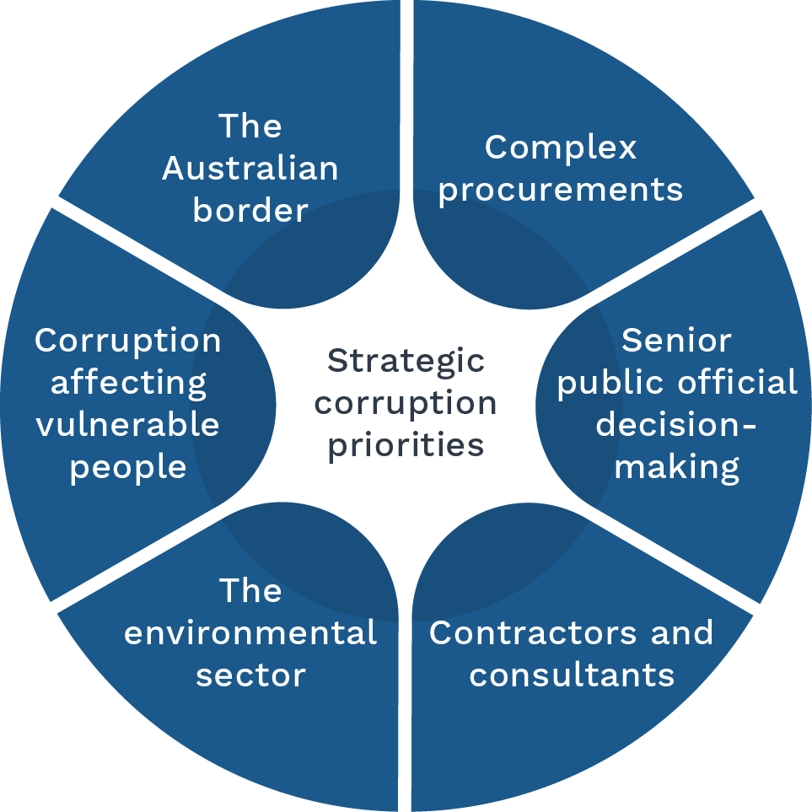

Corruption prevention priorities
The Commission has so far identified 3 dominant domains in which both perception and actuality of corrupt conduct is apparent. These are procurement, recruitment and the public-private interface. In all 3 domains, the mechanisms include the preferring of family, friends and associates (nepotism and cronyism); and the misuse of official information to gain an advantage.
The Commission has determined priority workstreams to facilitate corruption prevention outcomes. These are:
- the publication of guidance on ethical decision-making
- risks that arise at the public-private interface, where government uses the private sector to provide or deliver services
- delivery of the Australian Public Sector Anti-Corruption Conference 2026.

Oversight
The Commission is overseen by the Parliamentary Joint Committee on the National Anti-Corruption Commission (PJC-NACC) and the Inspector of the National Anti-Corruption Commission (the Inspector).

PJC-NACC
Section 177 of the NACC Act sets out the functions of the PJC-NACC, which include:
- considering recommendations for certain appointments
- examining reports tabled in Parliament relating to the Commission and the Inspector
- examining trends and changes in corruption, and reporting to Parliament on desirable changes to the functions, powers, procedures, structure and staffing of the Commission or Inspector
- reviewing the sufficiency of the Commission’s budget and finances and reporting on the outcome of that review.
The PJC-NACC cannot review operational decisions, methods or activities.

The Inspector
The Inspector is an independent officer of the Parliament. The Inspector’s functions include to:
- investigate allegations of serious or systemic corrupt conduct within the Commission
- investigate complaints of maladministration about the Commission
- audit the operations of the Commission to monitor its compliance with Commonwealth laws and detect agency maladministration and officer misconduct.
The Inspector can conduct joint investigations with the Commissioner, and with the Australian Federal Police (AFP) or a police service of a state or territory.

Commonwealth Ombudsman
In addition to the above mentioned oversight bodies, the Commission’s use of intrusive powers is subject to regular inspection by the Office of the Commonwealth Ombudsman. This covers the Commission’s use of:
- telecommunications interception, telecommunications data, stored communications and international production orders (under the Telecommunications (Interception and Access Act) 1979)
- controlled operations (under Part 1AB of the Crimes Act 1914)
- surveillance devices and computer access warrants (under the Surveillance Devices Act 2004).
The Commonwealth Ombudsman also conducts regular health checks of the Commission’s compliance culture.
The Commission is also required to report annually to the Minister for Home Affairs on the use of the powers listed above. After the cessation of each surveillance device or telecommunications interception and access warrant, the Commission also provides the Minister for Home Affairs with reports on each warrant obtained and its usefulness.
As a Commonwealth entity, the Commission is within the jurisdiction of the Auditor-General, and the Australian National Audit Office provides annual auditing of the Commission’s financial statements.

Integrity partners
The Commission is committed to taking a leading role in promoting integrity in governance. It does this by:
- participating in the Integrity Agencies Group, whose mission is to ensure that integrity is at the centre of the work of the public sector and that the Australian Public Sector (APS) approach to integrity is integrated, capable, agile and transparent, and whose membership includes a subset of the Commonwealth integrity agencies
- contributing to broader Commonwealth integrity initiatives, including the APS Reform Agenda.
As a member of the Integrity Agencies Group and the Criminal Justice and Law Enforcement Forum, the Commission consults regularly with partner integrity agencies.
The Commission’s participation in these forums supports knowledge-sharing and best practice in integrity policy, programming and agency operations.

Commonwealth integrity agencies
The Commission’s jurisdiction overlaps with that of other Commonwealth integrity agencies, including:
- Commonwealth Ombudsman (and related Ombudsman appointments)
- Australian Public Service Commissioner
- Merit Protection Commissioner
- Auditor-General
- AFP Commissioner
- Parliamentary Service Commissioner
- Parliamentary Service Merit Protection Commissioner
- Australian Information Commissioner
- CEO of the Australian Crime Commission
- Inspector-General of Intelligence and Security (IGIS)
- Inspector-General of Taxation
- Chief Executive Officer of the Tertiary Education Quality and Standards Agency
- Inspector-General of Biosecurity
- Inspector-General of Live Animal Exports
- Inspector-General of Water Compliance
- Inspector-General of the Australian Defence Force.
Functions of the Commission include overseeing investigations into corruption issues conducted by other Commonwealth agencies.
The Commission’s approach is guided by the principle of complementarity. Where another integrity agency is better placed or more appropriately equipped to deal with a corruption issue, the Commission will be inclined to refer the corruption issue to that agency. This will depend on the nature of the corruption issue and the capacity of the integrity agency to undertake the investigation and any perceptions of partiality that may arise. The Commission can also undertake a joint investigation with another agency.
If a Commonwealth integrity agency has previously concluded an investigation into a matter regarding the conduct of a public official, the Commission may only investigate the corruption issue if the Commissioner is satisfied that doing so is in the public interest.

Intelligence agencies
The Commission’s jurisdiction includes intelligence agencies and overlaps with that of the IGIS. If the Commission becomes aware that a corruption issue relates in any way to a security matter, the Commission must consult with the head of the Australian Security Intelligence Organisation.
If the Commission intends to exercise a power to require an IGIS official to give information or produce a document or thing that originated from, was collected by, or concerns the activities of an intelligence agency, the Commission must first consult the head of the intelligence agency and must consider, but is not bound by, the views of that head.
The Commission is in the process of negotiating an arrangement with heads of agencies within the National Intelligence Community, as required by section 239(1) of the NACC Act, relating to obtaining, storing, accessing, using or disclosing intelligence information relating to an intelligence agency.

Australian Parliament
The Commission engages with the Parliament to inform parliamentarians and their staff of their rights and obligations under the NACC Act, and enhance understanding of integrity issues.
A Memorandum of Understanding is in place between the Commission and the Attorney-General, the President of the Senate, and the Speaker of the House of Representatives in respect of parliamentary privilege.

Attorney-General’s Department
The Commission will continue to work cooperatively with the Attorney-General’s Department in relation to the Department’s role in developing domestic policy on anti-corruption and engagement in a range of international anti-corruption forums.

Department of Foreign Affairs
As required by the NACC Act, the Commission must consult with the Secretary of the Department of Foreign Affairs (DFAT) if a corruption investigation or a public inquiry relates to:
- a foreign official
- conduct in a foreign country of a person who is not an Australian citizen or permanent resident.
It will do so via an already established process and points of contact, and mindful of the wider national interests potentially at stake in that context.
The Commission recognises that corruption is a transnational issue that does not respect national boundaries. Accordingly, the Commission contributes to global anti-corruption efforts through engagement with other national anti-corruption agencies, and participation in regional and international anti-corruption forums. In this respect, the Commission is particularly focussed on cooperation with Pacific Island countries to build their anti-corruption capacity. It will continue to work cooperatively with DFAT in these forums.

State and territory integrity agencies
The Commission regularly engages with integrity and anti-corruption commissions in Australian states and territories through the Commissioners Forum and the Prevention Practitioners Forum. The Commission’s participation in these forums supports knowledge-sharing and the development of best practice in integrity policy, programming and agency operations.

Capability

Workforce
The number, capability, skills and experience of its staff is critical to the Commission’s ability to perform its key functions, and to fulfil its purpose efficiently and effectively.
The Commission continues to build its workforce in line with the staffing budget provided in the Portfolio Budget Statements 2025-2026. The organisational structure of the Commission is shown in Figure 2.
The CEO and 3 Deputy Commissioners report to the Commissioner. General Managers of 6 branches report directly to the CEO. The branches are: Enabling Services; Evaluation; Legal; Media, Communications, Corruption Prevention and Education; Operational Capabilities; and Operations. The Governance team also reports directly to the CEO.
The Commission is focused on attracting and retaining highly skilled and motivated staff to ensure it has the capacity to effectively undertake its functions and achieve its purpose.
The Commission is committed to maximising in-house resources and minimising use of contractors and consultants.
However, it will continue to retain outsourcing arrangements for some elements of its core work, particularly in the information and communications technology (ICT) sector. With a competitive labour market and skills shortages, it is not currently possible for the Commission to reduce outsourced work and bring these roles in-house, in line with the APS Strategic Commissioning Framework.

Figure 2: Organisational structure
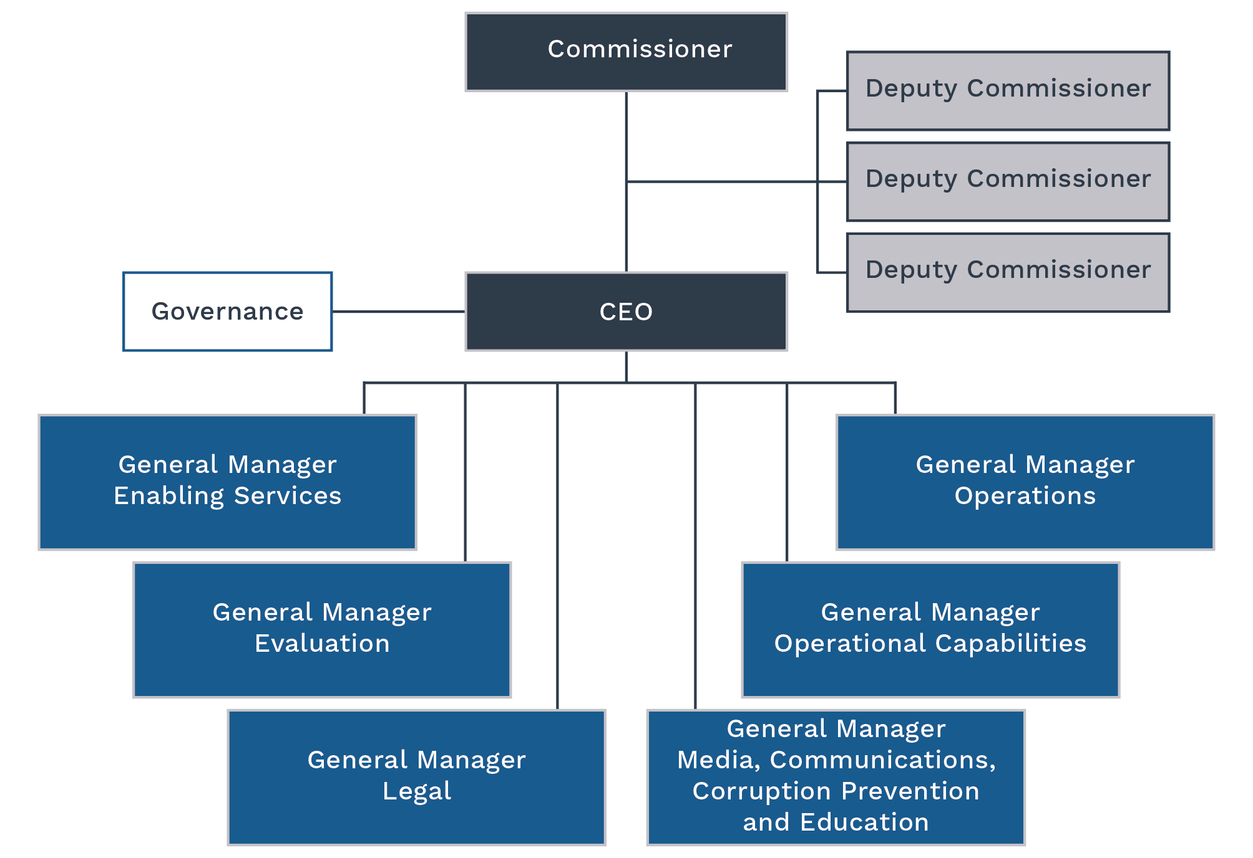
The Commission has implemented a learning and development framework, to ensure all employees develop and maintain the necessary skills to deliver business outcomes. This framework focuses on core elements such as induction, mandatory (ongoing essential learning) and role-specific development requirements to ensure the Commission complies with and maintains its obligations to employees, contractors, the government and the Australian public. The Commission maintains a centralised capability development budget to ensure all employees have equitable access to learning opportunities and that a consistent approach to core learning is implemented.
The Commission offers initiatives to support staff in the workplace and promote their physical and mental wellbeing, including generous flexible work provisions, access to an employee assistance program and access to an annual health and wellbeing reimbursement.
The Commission aspires to generate and retain corporate knowledge in the long term through retaining staff and providing pathways for internal progression: for example, from intake and triage officer, to assessment officer, to investigator or intelligence analyst.

Information and communications technology
In 2025–29, the Commission will continue to mature its ICT systems with a focus on data, information management and operational capabilities. The Commission will be open to exploring innovative technologies to support the agency to operate efficiently, effectively and securely.

Technical surveillance capability
The availability of contemporary technical surveillance capabilities is critical to the Commission’s ability to perform its key functions efficiently and effectively.
The Commission works with other law enforcement agencies to ensure it has access to the technical capabilities needed to conduct its own investigations.
The Commission prioritises working with state and territory law enforcement and integrity agencies to minimise reliance on jurisdictional agencies. During the life of this plan, the Commission will consider the efficiency of technical capabilities being provided by third parties and, where appropriate, will consider bringing these capabilities in-house.

Risk oversight and management

Integrity
The Commission is committed to upholding the highest standards of integrity, trustworthiness and effectiveness in its frameworks and decision-making processes. It strives to set a benchmark for excellence across the APS and meet the expectations of the Australian public.
The Commission’s frameworks and policies align with the Integrity Principles set out in the Commonwealth Integrity Management Framework. The Commission’s integrity framework incorporates a suite of policies to provide guidance to staff on gifts and benefits, conflict of interest management, and fraud and corruption control.
The Commission’s Fraud and Corruption Control Plan includes mechanisms to detect and report integrity issues. Targeted fraud and corruption risk assessments have been conducted to ensure control measures are adequate to protect the organisational integrity of the Commission.

Risk management
The Commission takes a strategic, consistent and structured approach to managing all types of risk, including enterprise, fraud and corruption, work health and safety, and business disruption risks. The Risk Management Policy and Framework (the Framework) sets out an approach to risk oversight, management and internal control that is integrated into planning, decision-making and operational activities. The Framework ensures the Commission satisfies its obligations under section 16 of the PGPA Act, while also supporting appropriate systems of governance.
Internal audit activities provide independent assurance on risk, controls, compliance and external accountability, and identify opportunities for continuous improvement.
The Commission takes a measured approach to risk, articulated in its risk appetite statement:
The Commission acknowledges risk as an unavoidable, natural part of business that when actively managed at all levels, enables the Commission to achieve its objectives. However, the Commission has no appetite for risks associated with the safety of our people and witnesses, or inadequate integrity standards within the NACC, including corruption, or conduct contrary to our standing as an independent anti-corruption commission.
The Commission’s key risks are principally addressed under 10 specific areas, identified as enterprise risks and outlined in Table 1.

Table 1: Enterprise risks
Enterprise risk | How the Commission manages the risk
The Commission fails to establish and implement legislatively compliant processes and activities. | The Commission's Governance Framework ensures that the Accountable Authority and Commissioner are supported to discharge their duties in compliance with relevant legislative requirements. The activities of the Commission are overseen by the Inspector and the PJC‑NACC.
The Commission fails to establish and grow operational and organisational cadence and achieve Commission outcomes. | Key activities in relation to organisational and operational performance are outlined in this Corporate Plan. This is supported by internal and external performance reporting and assurance activities such as business planning and internal audit activities.
The Commission fails to establish and build effective relationships. | A National Engagement Strategy has been established to ensure that each function commits to building connections with key stakeholders to ensure objectives are met and that the Commission meets its obligations as an Integrity agency.
The Commission fails to maintain control or security of its cyber, physical and information assets. | The Commission has frameworks in place that ensures adequate and effective controls are in place to manage the risks and mitigate the impacts of any threats relating to physical and information assets.
The Commission fails to attract, retain or maintain sufficient workforce capability. | The Commission regularly assesses and reviews its capability needs based on its operational requirements, risks and opportunities, and the skills required to ensure that objectives and obligations are met.
The Commission fails to establish organisational systems of control. | The Commission's overall control environment ensures that it meets its objectives and functions as well as promoting ongoing improvement to processes and outcomes. This includes a robust governance structure with additional oversight from the Audit and Risk Committee, internal audit activities, and external oversight by the Inspector and PJC‑NACC.
Excessive or serious instances of preventable physical or wellbeing injuries to our people or those who interact with the Commission. | The Commission takes a zero-tolerance approach to risks associated with the health, safety and wellbeing of staff and parties who interact with it. As well as frameworks ensuring compliance with work health safety requirements, the Commission focusses on consultation and collaboration with staff and stakeholders to ensure the maintenance of a safe and healthy workplace. Witness Liaison Officers provide further support to those who interact with the Commission.
The Commission does not have an ongoing sustainable funding and resource model to meet its statutory requirements in the medium and long term. | The Commission embeds continual review and monitoring of expenditure into the internal budget process. In addition, effective financial management and resource utilisation are key oversight components of the Corporate Governance and Audit and Risk Committees. The functions of the PJC‑NACC include reviewing the sufficiency of the Commission’s budget and finances.
The Commission fails to provide independent assurance to the Australian community that corrupt conduct involving Commonwealth public officials is prevented, detected, investigated and responded to appropriately. | The Commission provides assurance to the public through regular media communications, stakeholder engagement and educational resources. The Inspector of the NACC and PJC‑NACC have oversight powers to examine and report on the effectiveness of the Commission’s approach and activities.
The Commission fails to maintain awareness of, and seek solutions to, technological changes which impact its ability to collect evidence and intelligence as part of its investigations. | The Commission works closely with partner agencies and other experts to ensure that we are aware of, and are able to use where appropriate, new technologies to ensure our collection activities are not eroded. This includes chairing a Community of Practice with State and Territory integrity agencies to share information on these challenges. Frequent, targeted training is also provided to our staff.

Governance
The Commission’s governance structure provides a framework to identify, prevent, mitigate and report on enterprise and operational risks and promotes active engagement in the risk management process. While it is not possible to have a completely risk-free operating environment, the Commission is focused on further embedding the framework and developing the Commission’s risk culture and maturity.
The Commission’s Governance Framework comprises 2 streams covering corporate and operational governance. The Executive Leadership Committee provides strategic oversight of the Commission’s corporate and operational governance frameworks. The Commissioner chairs the Executive Leadership Committee and the Operations Governance Committee. The CEO chairs the Corporate Governance Committee and has established the WHS Committee and Consultative Committee in line with his responsibilities as accountable authority.
The Audit and Risk Committee supports the Accountable Authority by providing independent assurance to the accountable authority on the appropriateness of the Commission’s financial and performance reporting and systems of internal control, including risk management.

Figure 3: Governance structure
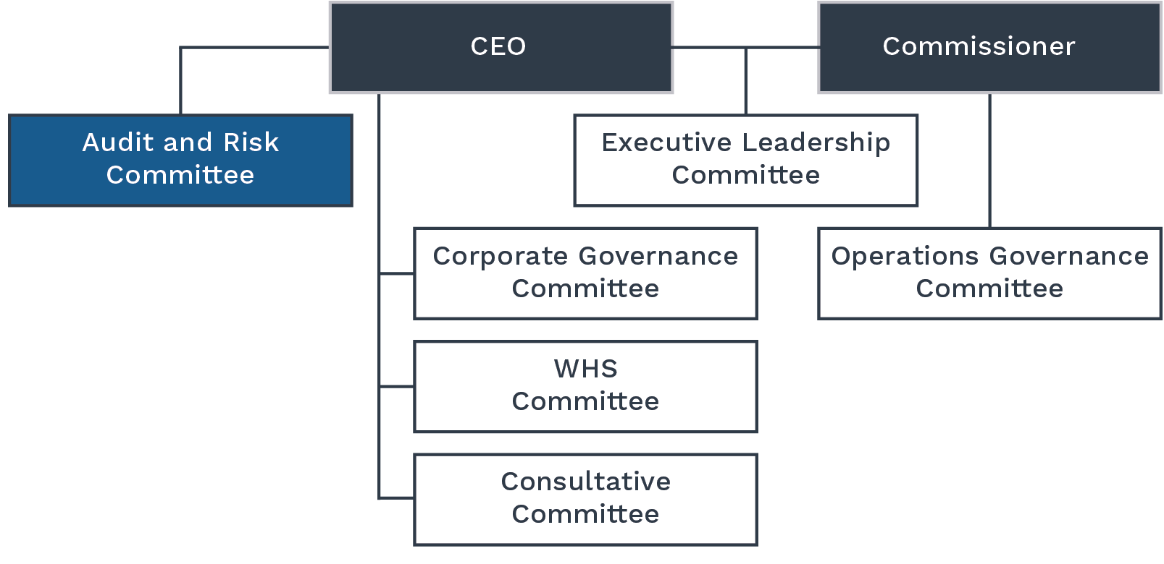

Performance

Performance measures and targets
The Commission has 3 key performance indicators (KPIs) for 2025–26 included in the Portfolio Budget Statements. These KPIs are linked to the Commission’s key activities.
Targets are per each financial year across the life of the plan.

KPI 1.1 Percentage of referrals assessed within 90 days of receipt
Target | 80%
Key activity | 2. Receiving and assessing referrals of alleged corrupt conduct.
Type of measure | Productivity
Target rationale | Efficiently actioning concerns from the public and progressing these, where appropriate, to investigation in a timely manner.
Methodology | The result is calculated by taking the number of referrals assessed within 90 days of receipt as a percentage of the total number of referrals assessed during the reporting period.
Changes from the previous year | Nil.

KPI 1.2 Percentage of investigations finalised within 2 years
Target | 60%
Key activity | 3. Conduct investigations into corruption issues that could involve serious or systemic corrupt conduct.
Type of measure | Productivity
Target rationale | Progressing investigations in an efficient manner and supporting the Commission’s purpose to investigate serious or systemic corruption in the Australian Government.
Methodology | The result is calculated by taking the number of investigations finalised within 2 years during the reporting period as a percentage of the total number of investigations finalised during the reporting period.
Changes from the previous year | Nil.

KPI 1.3 Number of corruption prevention and education products and engagements
Target | 100
Key activity | 5. Create and disseminate information and education to support corruption prevention.
Type of measure | Productivity
Target rationale | In line with the Commission’s purpose, this activity aims to ensure the Commission is providing sufficient materials and support to the other government agencies and the public.
Methodology | The result is a count of products created and engagements during the reporting period.
Changes from the previous year | Nil.

NACC Act reporting requirements
The NACC Act specifies reporting requirements on the performance of the Commissioner’s functions. These requirements provide a measure of the Commission’s activity and output.
In accordance with the National Anti-Corruption Commission Regulations 2023 (NACC Regulations), these requirements are outlined in Table 2.
The Commission monitors its performance against these through regular reporting.
Quarterly reports on progress against the external facing performance measures and the requirements outlined in the NACC Act are provided to the Corporate Governance Committee, Executive Leadership Committee and Audit and Risk Committee.
The Commission will publish results for these performance measures from the financial year in its Annual Report.

Table 2: NACC Act reporting requirements
No. | Requirement | Legislative reference
1 | Number of voluntary referrals received | NACC Act: s 271(2)(a)(i)  NACC Regulations: s 27(a)
2 | Number of mandatory referrals received | NACC Act: s 271(2)(a)(i)  NACC Regulations: s 27(b)
3 | Total number of corruption issues dealt with (decisions under s 41(1) and s 41(6)) | NACC Act: s 271(2)(a)(ii)  NACC Regulations: s 28(1)
4 | Number of corruption issues investigated by the Commission (decisions under s 41(1)(a)) | NACC Act: s 271(2)(a)(ii)  NACC Regulations: s 28(2)(a)
5 | Number of corruption issues investigated jointly by the Commission and a Commonwealth agency or a state or territory government entity (decisions under s 41(1)(b)) | NACC Act: s 271(2)(a)(ii)  NACC Regulations: s 28(2)(b)
6 | Number of corruption issues referred to a Commonwealth agency for investigation (decisions under s 41(1)(c)) | NACC Act: s 271(2)(a)(ii)  NACC Regulations: s 28(2)(c)
7 | Number of corruption Issues referred to a Commonwealth agency or a state or territory government entity for consideration (decisions under s 41(1)(d)) | NACC Act: s 271(2)(a)(ii)  NACC Regulations: s 28(2)(d)
8 | Number of corruption issues where the decision is to take no action (decisions under s 41(6)) | NACC Act: s 271(2)(a)(ii)  NACC Regulations: s 28(2)(e)
9 | Number of s 41(2) investigations completed | NACC Act: s 271(2)(a)(iii)  NACC Regulations: s 29(a)
10 | Number of s 41(2) investigations ongoing at the end of the reporting period (including any commenced prior to the reporting period) | NACC Act: s 271(2)(a)(iii)  NACC Regulations: s 29(b)
11 | Number of corruption issues referred to a Commonwealth agency for investigation (decisions under s 41(1)(c)), that were referred, investigated and completed during the reporting period | NACC Act: s 271(2)(a)(iv)  NACC Regulations: s 30(a)
12 | Number of corruption issues referred to a Commonwealth agency for investigation (decisions under s 41(1)(c)) where there is oversight by the Commissioner | NACC Act: s 271(2)(a)(iv)  NACC Regulations: s 30(b)
13 | Number of public inquiries completed | NACC Act: s 271(2)(a)(v)  NACC Regulations: s 31(1)(a)
14 | Number of public inquiries ongoing at the end of the reporting period (including any commenced prior to the reporting period) | NACC Act: s 271(2)(a)(v)  NACC Regulations: s 31(1)(b)
15 | Number of s 235 certificates issued by the Attorney-General | NACC Act: s 271(2)(a)(vi)  NACC Regulations: s 32(1)
16 | Number of s 236 (international relations) certificates issued by the Attorney-General | NACC Act: s 271(2)(a)(vii)  NACC Regulations: s 32(2)
17 | Extent to which corruption investigations have resulted in prosecution of persons for offences | NACC Act: s 271(2)(e)
18 | Extent to which corruption investigations have resulted in confiscation proceedings | NACC Act: s 271(2)(f)
19 | Number and type of applications made for judicial review | NACC Act: s 271(2)(g)(i)
20 | Outcomes of applications made for judicial review | NACC Act: s 271(2)(g)(i)
21 | Number of other court proceedings involving the Commissioner | NACC Act: s 271(2)(g)(ii)
22 | Outcomes of other court proceedings involving the Commissioner | NACC Act: s 271(2)(g)(ii)
23 | A description of the kinds of corruption risks, corruption vulnerabilities or measures to prevent corruption into which the public inquiry or inquiries were conducted | NACC Act: s 271(2)(a)(v)  NACC Regulations: s 31(2)
24 | A description of the corruption investigations conducted by the Commissioner during that year that the Commissioner considers raise significant issues for, or reflect developments in, Commonwealth agencies | NACC Act: s 271(2)(b)
25 | A description of any patterns or trends, and the nature and scope of corruption in Commonwealth agencies or by public officials that have come to the Commissioner’s attention during that year | NACC Act: s 271(2)(c)
26 | Any recommendations for changes to the laws of the Commonwealth or administrative practices of Commonwealth agencies that the Commissioner, as a result of performing the Commissioner’s functions during that year, considers should be made | NACC Act: s 271(2)(d)

nacc.gov.au

The full list of the Inspector’s role and powers is available at naccinspector.gov.au/role-and-powers-inspector

