


Corporate Plan

2026–30
nacc.gov.au
Further information
Enquiries about this report should be directed to the National Anti-Corruption Commission.
Phone: 1300 489 844
Website: nacc.gov.au
Post: GPO Box 605, Canberra ACT 2601
Address: 5 Constitution Avenue, Canberra ACT 2601
Copyright

© Commonwealth of Australia 2026
The material in this report is licensed under a Creative Commons Attribution — 4.0 international license, with the exception of:
- the Commonwealth Coat of Arms
- the National Anti-Corruption Commission logo
- any third-party material
- any material protected by a trademark
- any images and/or photographs.
More information on this CC BY license is set out as follows:
- Creative Commons website
- Attribution 4.0 international (CC by 4.0).
Attribution
The CC BY licence is a standard form licence agreement that allows you to copy and redistribute the material in any medium or format, as well as remix, transform and build upon the material.
This is on the condition that you provide a link to the licence, you indicate if changes were made and you attribute the material as follows:
National Anti-Corruption Commission
Corporate Plan 2026–30
Licensed from the Commonwealth of Australia under a Creative Commons Attribution 4.0 International licence.
ISSN: 2982-1282 (Online)
ISSN: 2982-1274 (Print)
Using the Commonwealth Coat of Arms
Guidelines for using the Commonwealth Coat of Arms are available from the Department of the Prime Minister and Cabinet website.

Acknowledgement of Country
In the spirit of reconciliation, the National Anti‑Corruption Commission (Commission) acknowledges the Traditional Custodians of Country throughout Australia and their connections to land, sea and community. We pay our respect to their Elders past and present and extend that respect to all Aboriginal and Torres Strait Islander peoples today.
Integrity at Our Heart
This artwork, Integrity at Our Heart, tells the story of the Commission’s mission to enhance integrity within the Commonwealth public sector.
It is made up of many multicoloured strokes, depicting our team’s many weaving histories. At the core of the artwork are 3 white patterned rings, representing detecting, deterring and preventing corruption. Our approach is fearless but fair and we work towards our goals with integrity, determination and courage. We are on a journey to build a culture of unity, inclusion and trust as we grow.
Our people working together are represented by white dots between each of the lines. At the heart of the artwork is the central element, encapsulating our commitment to contributing to reconciliation as we work to create a culturally safe environment where First Nations staff and partners feel respected and included.
The artwork concept and narrative were developed by Navada Currie. Navada is a Mununjali and Kabi Kabi artist at Gilimbaa.
Contents
Commissioner’s foreword 6
Introduction 8
Purpose 10
Key activities 14
Areas of operation 14
Detecting corruption 14
Receiving and assessing referrals 15
Conducting investigations 17
Referring corruption issues to other Commonwealth agencies for investigation 19
Creating and disseminating corruption prevention information and education to build a strong public sector integrity culture 19
Operating context 21
Operating environment 21
Oversight 23
Capability 30
Risk oversight and management 34
Performance 42
Performance measures and targets 42
NACC Act reporting requirements 53

Commissioner’s foreword

Kylie Kilgour
Acting National Anti-Corruption Commissioner
The National Anti-Corruption Commission’s Corporate Plan 2026–30 describes the organisation’s strategic direction for the next 4 years.
The Commission was established in July 2023 to provide independent assurance to the Australian community that corrupt conduct involving Commonwealth public officials is prevented, detected, investigated and responded to appropriately.
We also play an important role in enhancing integrity in the Commonwealth public sector by deterring, detecting and preventing corrupt conduct involving Commonwealth public officials. Our role complements other significant activities undertaken by a complex ecosystem of Commonwealth integrity agencies, state and territory anti-corruption commissions, the public sector and civil society stakeholders.
Integrity in the Commonwealth public sector is critical to ensuring that public officials’ powers and responsibilities are exercised honestly, impartially and in the public interest. It is also essential to ensuring that public funding and resources are not misused for corrupt purposes, particularly in current times of increasing constraints on the Federal budget and cost-of-living stressors in the Australian community.
The Commission will maintain a steadfast focus on resolving investigations, promoting practices that prevent corrupt conduct and publicly communicating about our role and progress over the next 4 years.

Kylie Kilgour
Acting National Anti-Corruption Commissioner

Introduction

Philip Reed
Chief Executive Officer
As the Chief Executive Officer and Accountable Authority of the National Anti‑Corruption Commission, I am pleased to present the Commission’s 2026–30 Corporate Plan as required under section 35(1)(b) of the Public Governance, Performance and Accountability Act 2013 (PGPA Act).
This plan is prepared for the financial year 2026–27 and covers the 4-year period 2026–30.
The plan identifies the purpose, guiding principles, key activities, operating context and performance measures for the Commission for the next 4 years. It details the opportunities and challenges we face and how we will measure and assess the Commission’s performance in achieving its purpose.
This reporting period will be a significant delivery phase for the Commission. We will see the publication and promotion of more outcomes from our investigative work which will ensure that both the Commonwealth public sector and the public gain greater awareness of the important work of the Commission in providing assurance that corrupt conduct is being detected and deterred.
At the core of the Commission is its people which has grown to more than 240 expert and committed individuals in 5 offices across Australia. We will continue to invest in the welfare and upskilling of our staff in delivering the core work of the Commission in line with our performance measures.
Our focus will remain on delivering our strategic and operational priorities effectively by embedding systems that support continuous improvement, while remaining responsive to ever-changing demands in a complex and challenging operating environment.

Philip Reed
Chief Executive Officer

Purpose
The National Anti‑Corruption Commission is an independent Commonwealth entity, established under the National Anti‑Corruption Commission Act 2022 (Cth) (NACC Act), which was established to provide independent assurance to the Australian community that corrupt conduct involving Commonwealth public officials is prevented, detected, investigated and responded to appropriately.
Our mission is to enhance integrity in the Commonwealth public sector by deterring, detecting and preventing corrupt conduct involving public officials through education, monitoring, investigation, reporting and referral.
Under the NACC Act, the Commission can investigate alleged corrupt conduct involving Commonwealth public officials.
Public officials include parliamentarians (including ministers), and staff members of Commonwealth agencies. Staff members of Commonwealth agencies include individuals employed by or engaged in assisting the agency, and individuals responsible for delivering goods or services to or on behalf of the agency under a Commonwealth contract administered by the agency. Corrupt conduct is:
- conduct by a public official that involves a breach of public trust. This means a public official using a power or discretion for a purpose for which it was not conferred, typically a private purpose.
- conduct by a public official that involves an abuse of office. This means a public official using their position to gain a private advantage.
- misuse of official information. This means a public official or former public official making improper use of information they obtained in their official capacity.
- conduct by anyone, including a public official, to cause a public official to perform their public functions other than honestly or impartially.
The Commission cannot investigate concerns relating to state, territory or local government officials. Each state and territory has a similar integrity or anti-corruption commission that may be able to investigate those matters.
The Commission is not a complaints-handling agency, nor an administrative decisions review authority. Making a referral to the Commission is not like making a referral to the Ombudsman or an application to the Administrative Reviews Tribunal: the Commission does not adjudicate on individual complaints.
Referrals to the Commission are not individual initiating processes on which a referrer is entitled to an adjudication, but a source of information that, with other information, can help the Commission identify and decide what it should investigate, and where it should focus in the public interest, to have the optimal impact in deterring and preventing corrupt conduct.
Often that means the Commission will focus on matters which are not and have not been the subject of investigation by other agencies, rather than those which have been, or are, under investigation elsewhere.
To investigate a corruption issue, the Commission must have information raising the possibility that a person has done or could do something that:
- involves, or could involve, a public official
- is, or could be, corrupt conduct under the NACC Act
- could involve serious or systemic corrupt conduct.
The NACC Act does not define serious or systemic corrupt conduct. Under section 279 of the NACC Act, the Commission has issued guidance on what is serious or systemic corrupt conduct to assist public officials with the operation of the Act, which is available on the Commission website.
‘Serious’ means significant, severe or grave. It relates to the scale, impact and/or gravity of the conduct. Conduct that technically meets the definition of corrupt conduct but does not result in or risk significant harm or improper benefit is unlikely to be considered serious.
‘Systemic’ means ‘something that affects or relates to an entire system, organisation or body’.
‘Systemic corrupt conduct’ refers to conduct that is a pattern of behaviour that relates to a process or agency. It refers to conduct that is the product of a process or system. Its hallmark is that there will be multiple instances, typically involving multiple officials, and that those instances reflect weaknesses or failures in a system.

Guiding principles
Five guiding principles inform how the Commission operates and makes decisions.
Independent | The Commission operates independently of government and impartially.
Value-adding | The Commission focuses on matters where it is best positioned to add value in the public interest by deterring or preventing corruption in circumstances where other agencies are less well-equipped to do so. This means the Commission is less likely to investigate a matter if another agency has already addressed it or is well-equipped to do so.
Evidence-based | The Commission uses evidence to make its decisions, findings and recommendations.
Data driven | The Commission is informed by data. This means the Commission uses data to form insights and identify current trends and emerging risks and issues.
People focused | The Commission cares for people: we have duties to care for our staff, and also those who engage with it and are affected by its operations. This means the Commission invests in and cares for its workforce to ensure they have the skills, knowledge and capability to succeed.  It also means the Commission endeavours to mitigate the inevitable distress that individuals dealing with or affected by its operations may sometimes experience.

Key activities

Areas of operation
To achieve its purpose and execute its mission, the Commission has 2 areas of operation. These are:
- deterrence through detection, investigation and exposure
- prevention through engagement and education.
These areas of operation are reflected in the Commission's 5 key activities included in the Portfolio Budget Statements 2026-27 and as follows:
- Detecting corruption and enhancing the Commonwealth public sector’s capabilities to detect corruption.
- Receiving and assessing referrals of alleged corrupt conduct.
- Conducting NACC investigations into corruption issues that could involve serious or systemic corrupt conduct. These investigations may be undertaken jointly with other Commonwealth agencies or with state or territory agencies.
- Referring allegations of corrupt conduct to other Commonwealth agencies for investigation.
- Creating and disseminating information and education to enhance the effectiveness and maturity of approaches to corruption prevention and build a strong integrity culture across the public sector.

Detecting corruption
The Commission detects corruption through a variety of methods, including:
- voluntary referrals made through the Commission’s webform, by phone or by post
- mandatory referrals from agency heads who become aware of a corruption issue concerning a staff member of their agency which could involve serious or systemic corrupt conduct
- information received by the Commission in other ways (including media reports)
- strategic intelligence and data analysis by the Commission
- information obtained during a Commission investigation that identifies another corruption issue.
The Commission’s detection work includes proactive initiatives that seek to identify corrupt conduct that would otherwise remain hidden. This work, informed by our strategic corruption priorities, targets the most significant corruption issues within the Commission’s jurisdiction.
As well as informing investigations, these detection initiatives support corruption prevention work. They identify vulnerabilities the Commission can address and inform strategies that can be shared with other agencies.

Receiving and assessing referrals
The Commission assesses referrals to ascertain whether they are within jurisdiction (that is, they relate to a Commonwealth public official), whether they appear to raise a corruption issue, whether they could involve serious or systemic corrupt conduct, and if so whether and how to deal with them.
The Commission may seek further information in relation to a referral, including from the person who made the referral, agencies that may hold relevant material or open-source material.
The Commission can decide not to take any action in relation to a referral. The Commission does not have to consider or respond to every referral it receives. However, as a matter of courtesy, the Commission usually provides a response to each person who makes a referral, if they provide contact details.
If a referral raises a corruption issue, the Commission may deal with it in one or more of the following ways:
- if the issue could involve serious or systemic corrupt conduct, investigate the issue alone or jointly with a Commonwealth agency or a state or territory government entity
- refer the issue to the Commonwealth agency the issue relates to for them to investigate
- refer the issue to a Commonwealth agency or state or territory government entity for them to consider
- take no action.
In addition, the Commissioner may, at any time, reconsider whether or how to deal with a corruption issue.

Preliminary investigations
The Commissioner may conduct a preliminary investigation to decide:
- whether a referral raises a corruption issue, including whether it is serious or systemic
- and if so, whether or how to deal with the issue.
A preliminary investigation helps the Commission find out more information about the referral as part of the assessment process. The Commission can use some of its investigatory powers under the NACC Act in a preliminary investigation, such as the compulsory provision of information, documents or materials.

Conducting investigations
The Commission’s investigation teams investigate corruption issues and gather information to prove or disprove them. They do this by obtaining documents and records, analysing information and interviewing witnesses. Investigations can be undertaken solely by the Commission, or jointly with another Commonwealth or state or territory government agency.
The Commission has extensive information-gathering powers under the NACC Act and other relevant legislation. For example, the Commission can:
- compel the production of documents or other things
- compel individuals to provide information, which could involve participation in a hearing
- obtain search warrants and warrants to intercept telecommunications and use surveillance devices.

Commission hearings
Under the NACC Act, the Commissioner has the power to summon a person to attend a hearing to give evidence or produce a document or other thing relevant to a corruption investigation.
Hearings must be held in private, except in exceptional circumstances and it is in the public interest. Whether exceptional circumstances exist and public interest considerations are satisfied is decided on a case-by-case basis.

Finalising an investigation
The Commissioner can decide at any time during a corruption investigation that no further action should be taken and discontinue the investigation.
That decision could be made because, for example, the investigation appears to predominantly involve criminal conduct that is more appropriately dealt with in the criminal justice system or because, for example, the corruption investigation is unlikely to find evidence of corrupt conduct and the resources that would otherwise be applied to that investigation are better utilised investigating other corruption issues.
At the completion of an investigation, the Commissioner must prepare a report on the investigation for the Attorney-General (unless the investigation is about the Attorney-General, in which case the report would be made to the Prime Minister).
The report must set out:
- the Commissioner’s findings or opinions on the corruption issue. This can include a finding that a person has engaged in corrupt conduct, which is an administrative finding of fact, not a finding of criminal guilt
- a summary of the evidence and other material on which those findings or opinions are based
- any recommendations the Commissioner sees fit to make and the reasons for those recommendations. If the Commission finds evidence of a criminal offence, it may send a brief of evidence to the Commonwealth Director of Public Prosecutions for them to consider whether there is sufficient evidence for charges to be laid.
If the Commission has held a public hearing, it must table the report in Parliament. The Commission can also publish reports if satisfied it is in the public interest to do so.

Joint investigations
The Commission may investigate corruption issues jointly with another Commonwealth, state or territory government agency, for example if the investigation would benefit from the specialist knowledge of the other agency and the special powers of the Commission.

Referring corruption issues to other Commonwealth agencies for investigation
The Commissioner may deal with a corruption issue by referring it to the relevant agency for investigation, provided the Commissioner is satisfied the agency has the capability to investigate it. The Commissioner can decide to oversee the investigation, issue directions to the agency in relation to the investigation or leave the agency to conduct the investigation independently.
The Commissioner may require the agency to provide progress reports and/or a completion report to the Commission at specified intervals.
The Commissioner may make comments, recommendations or require follow-up action on an investigation, its outcome and/or preventive measures that have been or could be put in place to address ongoing corruption risks and vulnerabilities.

Creating and disseminating corruption prevention information and education to build a strong public sector integrity culture
The Commission educates public officials, the public sector and the public about corruption risks and vulnerabilities to enhance corruption prevention strategies and to build a strong integrity culture. The purpose of these activities is to build resistance to corrupt conduct, encourage people to report it, and create a culture in which corruption is not tolerated.
The Commission provides guidance to public officials who are mandatory referrers about their obligations to report suspected serious or systemic corrupt conduct concerning staff of their agencies, and how they can do so.
The Commission provides guidance and information to help public officials understand the importance of integrity in preventing corruption, and to address vulnerabilities to corruption within their agencies.
The Commission takes opportunities to speak at conferences and other events to explain and promote the role of the Commission and corruption risks and vulnerabilities to a wider audience, including members of the business community and the public.
It also publishes corruption prevention resources on its website to build public understanding.
To provide transparency and operate as a deterrent to corrupt conduct, the Commission publishes regular updates and statistics about its activities.
The Commission can conduct public inquiries into corruption risks and vulnerabilities, and measures to prevent corruption in Commonwealth agencies and programs.

Operating context

Operating environment
The Commission continues to operate under high public scrutiny and expectation.
The Commission works with other Commonwealth agencies to detect and prevent corruption, while also independently assessing and investigating corruption issues that involve those agencies.
The Commission recognises the importance of exposing corrupt conduct and building public awareness of how corruption can be detected and prevented. It is also conscious that its work should be subject to public scrutiny and that it needs to operate with as much transparency as possible.
However, much of the Commission’s work is necessarily confidential and there are constraints on what can permissibly or properly be done openly. In accordance with the governing legislation, the Commission will conduct public hearings when the circumstances and the public interest justify an exception to the general rule that they be held in private.

Environmental scanning and intelligence gathering
The Commission monitors the integrity landscape and shares insights and analysis with other agencies to enhance their awareness of corruption issues. Referrals received by the Commission are one way in which it identifies trends in the nature and level of corruption within the Commonwealth of Australia.
The Commission also conducts the biennial Commonwealth Integrity Survey to build an evidence‑based understanding of the nature and extent of perceptions of corruption across the Commonwealth public sector. The Commission shares results of the survey with participating agencies to support their corruption prevention efforts and help identify the impact of those efforts over time.
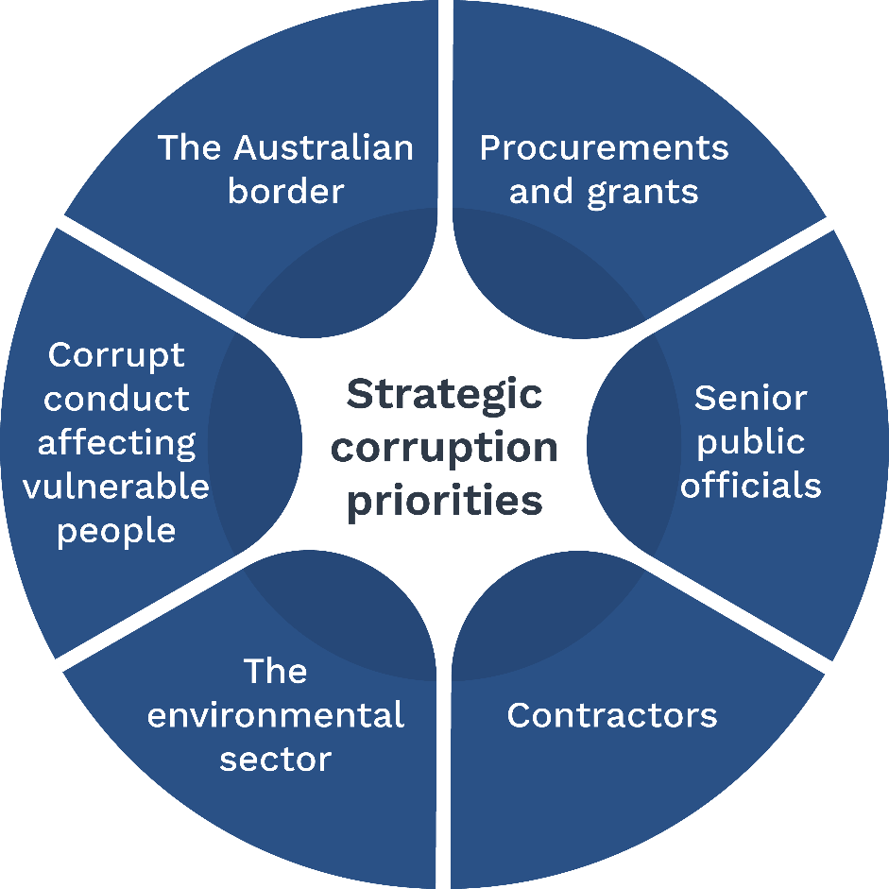

Strategic corruption priorities
To assist in prioritising its resources effectively and efficiently, the Commission has 6 strategic corruption priorities.
These priorities assist in focusing the Commission’s detection, investigative and prevention activities.
The current strategic corruption priorities relate to corrupt conduct:
- at the Australian border
- in procurements and grants
- involving senior public officials
- involving contractors
- affecting the environmental sector
- affecting vulnerable people.
The Commission reviews these priorities each year to consider how its work is engaging with these issues and whether the priorities need to be adjusted in response to changes in the broader integrity environment.

Oversight
The Commission is overseen by the Parliamentary Joint Committee on the National Anti-Corruption Commission (PJC-NACC) and the Inspector of the National Anti-Corruption Commission (the Inspector). In addition, some functions of the Commission are overseen by the Commonwealth Ombudsman and the Commonwealth Auditor-General.

PJC-NACC
Section 177 of the NACC Act sets out the functions of the PJC-NACC, which include:
- considering recommendations for certain appointments
- examining reports tabled in Parliament relating to the Commission and the Inspector
- examining trends and changes in corruption, and reporting to Parliament on desirable changes to the functions, powers, procedures, structure and staffing of the Commission or Inspector
- reviewing the sufficiency of the Commission’s budget and finances and reporting on the outcome of that review.
The PJC-NACC cannot review the Commission’s operational decisions, methods or activities.

The Inspector
The Inspector is an independent officer of the Parliament. Section 184 of the NACC Act sets out the functions of the Inspector, which include to:
- investigate allegations of serious or systemic corrupt conduct within the Commission
- investigate complaints of maladministration about the Commission
- audit the operations of the Commission to monitor its compliance with Commonwealth laws and detect agency maladministration and officer misconduct.
The Inspector can conduct joint investigations with the Commissioner, and with the Australian Federal Police (AFP) or a police service of a state or territory.
The Commission has a Memorandum of Understanding with the Inspector to facilitate the performance of the Inspector’s functions.

Commonwealth Ombudsman
In addition to the oversight functions of the PJC-NACC and the Inspector, the Commission’s use of intrusive powers is subject to regular inspection by the Office of the Commonwealth Ombudsman. This covers the Commission’s use of and compliance with:
- telecommunications interception, telecommunications data, stored communications and international production orders (under the Telecommunications (Interception and Access Act) 1979 (Cth))
- controlled operations and integrity testing (under the Crimes Act 1914 (Cth))
- surveillance devices and computer access warrants (under the Surveillance Devices Act 2004 (Cth)).
The Commonwealth Ombudsman also conducts regular health checks of the Commission’s compliance culture.
The Commission is also required to report annually to the relevant Minister on the use of the powers listed above. After the cessation of each surveillance device or telecommunications interception and access warrant, the Commission also provides the Minister for Home Affairs with reports on each warrant obtained and its usefulness.

Commonwealth Auditor-General
As a Commonwealth entity, the Commission is within the jurisdiction of the Auditor-General. The Australian National Audit Office provides annual auditing of the Commission’s financial statements.

Integrity partners
The Commission is committed to taking a leading role in promoting integrity in the Commonwealth public sector. It does this by:
- participating in the Integrity Agencies Group, whose mission is to ensure that integrity is at the centre of the work of the public sector and that the Australian Public Sector (APS) approach to integrity is integrated, capable, agile and transparent, and whose membership includes a subset of the Commonwealth integrity agencies
- contributing to broader Commonwealth integrity initiatives, including the APS Reform Agenda.
As a member of the Integrity Agencies Group, the Commission consults regularly with partner integrity agencies. The Commission’s participation in these forums supports knowledge-sharing and best practice in integrity policy, programming and agency operations.

Commonwealth integrity agencies
Matters referred to the Commission may come within the jurisdiction of other Commonwealth integrity agencies, including:
- Commonwealth Ombudsman (and related Ombudsman appointments)
- Australian Public Service Commissioner
- Merit Protection Commissioner
- Auditor-General
- AFP Commissioner
- Parliamentary Service Commissioner
- Parliamentary Service Merit Protection Commissioner
- Australian Information Commissioner
- CEO of the Australian Crime Commission
- Inspector-General of Intelligence and Security (IGIS)
- Inspector-General of Taxation
- Chief Executive Officer of the Tertiary Education Quality and Standards Agency
- Inspector-General of Biosecurity
- Inspector-General of Live Animal Exports
- Inspector-General of Water Compliance
- Inspector-General of the Australian Defence Force.
Functions of the Commission include overseeing investigations into corruption issues conducted by other Commonwealth agencies.
The Commission’s approach is guided by the principle of complementarity. Where another integrity agency is better placed or more appropriately equipped to deal with a corruption issue, the Commission will usually refer the corruption issue to that agency. This will depend on the nature of the corruption issue and the capacity of the integrity agency to undertake the investigation and any perceptions of partiality that may arise. The Commission can also undertake a joint investigation with another agency.
If a Commonwealth integrity agency has previously concluded an investigation into a matter regarding the conduct of a public official, the Commission may only investigate the corruption issue if the Commissioner is satisfied that doing so is in the public interest.

Intelligence agencies
The Commission’s jurisdiction includes intelligence agencies and overlaps with that of the IGIS. If the Commission becomes aware that a corruption issue relates in any way to a security matter, the Commission must consult with the head of the Australian Security Intelligence Organisation.
If the Commission intends to exercise a power to require an IGIS official to give information or produce a document or thing that originated from, was collected by, or concerns the activities of an intelligence agency, the Commission must first consult the head of the intelligence agency and must consider, but is not bound by, the views of that head.
The Commission has negotiated an arrangement with heads of agencies within the National Intelligence Community, as required by section 239(1) of the NACC Act, relating to obtaining, storing, accessing, using or disclosing intelligence information relating to an intelligence agency.

Australian Parliament
The Commission engages with the Parliament to increase awareness and understanding of the various obligations under the NACC Act as they apply to parliamentarians and their staff. In addition, this engagement aims to promote integrity in public office.
Parliamentarians are agency heads under the NACC Act and are subject to the same mandatory reporting obligations as other Commonwealth agency heads.
The powers of the Commission are subject to and do not override parliamentary privilege (the law relating to the powers, privileges and immunities of each House of Parliament, the members of each House, or the committees of each House and joint committees of both Houses).
The Parliament recognises that the Commission’s functions include the investigation of suspected corrupt conduct involving parliamentarians and their staff.
The Commission has a Memorandum of Understanding (MOU) with the Attorney-General, the President of the Senate and the Speaker of the House of Representatives. The MOU establishes agreed processes for the exercise of the Commission’s powers in circumstances where issues of parliamentary privilege could arise, to ensure that parliamentary privilege is respected while permissible action by the Commission to detect and investigate corrupt conduct is not inhibited.

Department of Foreign Affairs and Trade
As required by the NACC Act, the Commission must consult with the Secretary of the Department of Foreign Affairs and Trade (DFAT) if a corruption investigation or a public inquiry relates to:
- a foreign official
- conduct in a foreign country of a person who is not an Australian citizen or permanent resident.
It will do so via an already established process and points of contact, and mindful of the wider national interests potentially at stake in that context.
The Commission recognises that corruption is a transnational issue that does not respect national boundaries. Accordingly, the Commission contributes to global anti-corruption efforts through engagement with other national anti-corruption agencies, and participation in regional and international anti-corruption forums. In this respect, the Commission is particularly focused on cooperation with Pacific Island countries to build their anti-corruption capacity. It will continue to work cooperatively with DFAT in these forums.

Domestic and international partners
The Commission works cooperatively with the Attorney-General’s Department and the Department of Home Affairs to support the development of domestic anti-corruption policy and engagement in a range of international anti-corruption efforts.

State and territory government agencies
The Commission regularly engages with state and territory law enforcement, anti-corruption and integrity commissions through established forums, including the Commissioners and CEOs forum, the Assessments Community of Practice (CoP), the Capabilities CoP, the Witness Liaison CoP, the Prevention Practitioners Forum, the National Anti-corruption Investigation Network, the National Investigations Symposium and the Australian Public Sector Anti-Corruption Conference. Participation in these forums supports knowledge-sharing and the development of best practice in integrity policy, programs and operational approaches.

Capability

Workforce
The Commission’s executive comprises the National Anti-Corruption Commissioner (Commissioner), the CEO, 3 Deputy Commissioners and 6 General Managers at the Senior Executive Service (SES) level. The organisational structure of the Commission is shown in Figure 2.
The Commissioner is responsible for all operational matters within the Commission. The 3 Deputy Commissioners report directly to the Commissioner and assist them in managing the Commission’s functions under the NACC Act.
The General Managers are each responsible for one of the Commission’s 6 branches:
- Enabling Services
- Evaluation
- Legal
- Media, Communications, Corruption Prevention and Education
- Operational Capabilities
- Operations.
The General Managers report to both the CEO and Commissioner.
The number, capability, skills and experience of its staff is critical to the Commission’s ability to perform its key functions, and to fulfil its purpose efficiently and effectively.
The Commission continues to build its workforce in line with its ASL provided in the Portfolio Budget Statements 2026–27.

Figure 2: Organisational structure
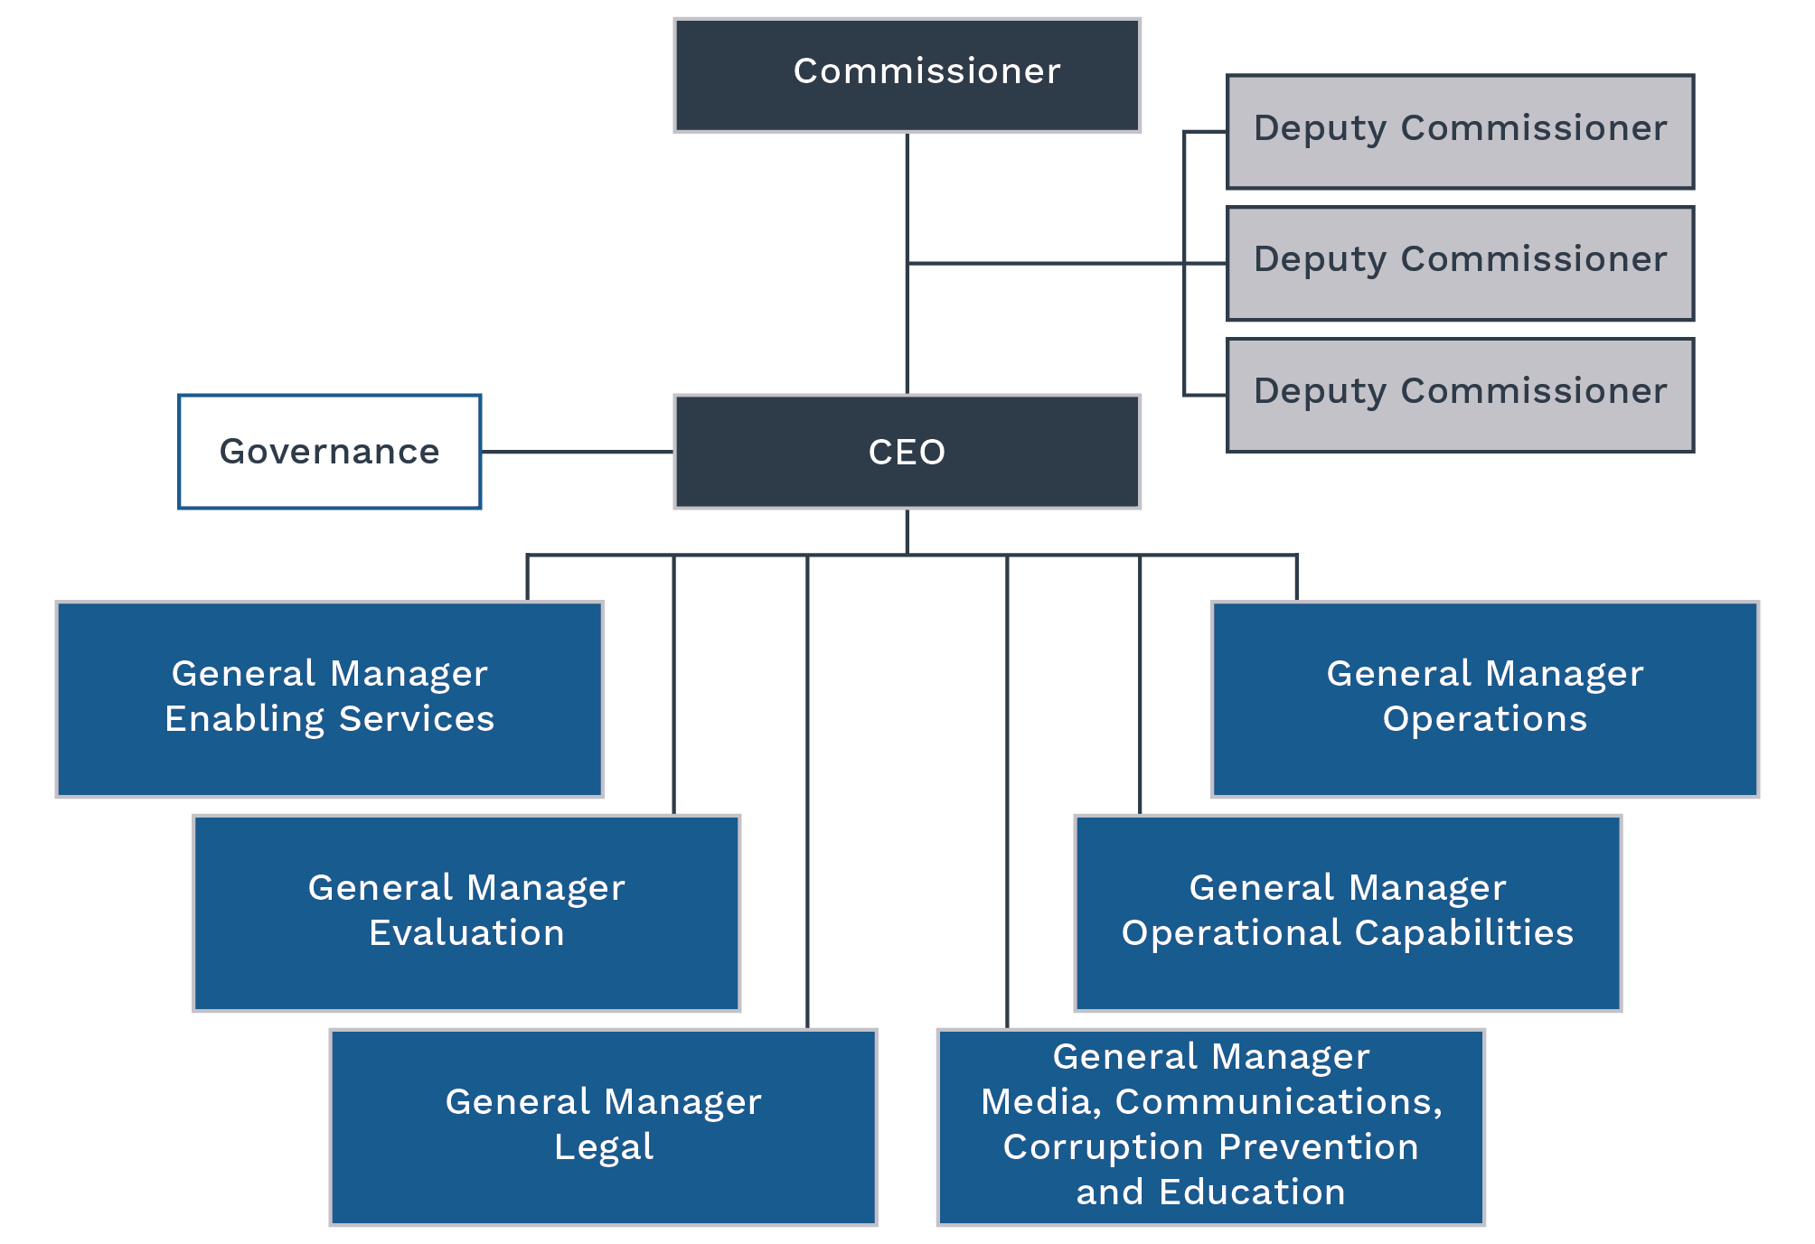

Recruitment, retention and outsourcing arrangements
The Commission is focused on attracting and retaining highly skilled and motivated staff to ensure it has the capacity to effectively undertake its functions and achieve its purpose. This will be assisted through the development and implementation of the Commission's strategic workforce plan in late 2026.
The Commission operates in line with the APS Strategic Commissioning Framework. Core work is done in-house in most cases, and any outsourcing of core work is minimal and aligns with the limited circumstances permitted under the framework.
The Commission is committed to maximising in-house resources and minimising the use of contractors and consultants. However, it will continue to outsource arrangements for some elements of its core work, particularly in the information and communications technology (ICT) sector. With a competitive labour market and skills shortages, it is not currently possible for the Commission to reduce outsourced work and bring these roles in-house, in line with the framework.

Learning and development
The Commission has implemented a learning and development framework which aligns with the Australian Public Service (APS) Learning and Development Strategy, to ensure all employees develop and maintain the necessary skills to deliver business outcomes. This framework focuses on core elements such as induction, mandatory (ongoing essential learning) and role-specific development requirements to ensure the Commission complies with and maintains its obligations to employees, contractors, the government and the Australian public.
The Commission has refreshed its essential learning requirements to address key Australian Government requirements particularly in relation to cyber security awareness and the use and application of artificial intelligence.

Workplace culture and staff wellbeing
Continued investment in leadership, employee wellbeing, integrity and enhancing inclusive culture strategies reinforces our commitment to retaining and developing talent.
The Commission maintains a centralised capability development budget to ensure all employees have equitable access to learning opportunities and a consistent approach to core learning is provided.
The Commission offers initiatives to support staff in the workplace and promote their physical and mental wellbeing, including generous flexible work provisions, access to an employee assistance program, access to health-related supports (such as annual skin checks and flu vaccination vouchers) and access to an annual reimbursement towards expenses that support improved health and wellbeing.

Information and communications technology
In 2026–30, the Commission will continue to mature its ICT systems with a focus on data analytics, information management and operational capabilities.
The Commission will develop a sound foundation to leverage the benefits of artificial intelligence capabilities to support our workforce and operational priorities. The Commission will develop frameworks and governance mechanisms to ensure artificial intelligence capabilities meet ethical and security standards, so they work alongside, and do not replace, human reasoning.

Surveillance capability
The availability of contemporary surveillance capabilities is critical to the Commission’s ability to perform its key functions efficiently and effectively.
The Commission works with other law enforcement agencies to ensure it has access to the surveillance capabilities needed to conduct its own investigations.
The Commission prioritises working with state and territory law enforcement and integrity agencies to minimise reliance on jurisdictional agencies. During the life of this plan, the Commission will consider the efficiency of the surveillance capabilities being provided by third parties and, where appropriate, will consider bringing these capabilities in-house.

Risk oversight and management

Integrity
Maintaining high standards of integrity is core to the Commission’s commitment to set a benchmark for excellence across the APS and meet the expectations of the Australian public.
The Commission strives to uphold the highest standards of integrity, trustworthiness and effectiveness in its frameworks, policies and decision-making processes which align with the Integrity Principles set out in the Commonwealth Integrity Management Framework.
The Commission’s integrity framework incorporates a suite of policies to support staff to manage integrity risk in their day-to-day work, including on conflict-of-interest management, gifts and benefits, secondary employment and fraud and corruption control.
The Commission’s Fraud and Corruption Control Plan includes mechanisms to prevent, detect and report integrity issues. Targeted fraud and corruption risk assessments are routinely conducted to ensure control measures are adequate to protect the organisational integrity of the Commission.

Risk management
The Commission takes a strategic and consistent approach to managing all types of risk, including enterprise, fraud and corruption, work health and safety, child safety and operational risks.
The Commission takes a measured approach to risk as articulated in its risk appetite statement:
The Commission acknowledges risk as an unavoidable, natural part of business that, when actively managed at all levels, enables the Commission to achieve its objectives. However, the Commission has no appetite for risks associated with the safety of our people and witnesses, or inadequate integrity standards within the NACC, including corruption or conduct contrary to our standing as an independent anti-corruption commission.
The Commission’s Risk Management Framework (the Framework) sets out an approach to risk oversight, management and internal control that is integrated into planning, decision-making and operational activities. The Framework includes the Risk Management Policy, Guide and Risk Appetite Statement to ensure the Commission is consistent with the Commonwealth Risk Management Policy and satisfies its obligations under section 16 of the PGPA Act, while also supporting appropriate systems of governance.
The internal audit function provides independent assurance on risk, controls, compliance and external accountability, and identifies opportunities for continuous improvement. This is overseen by the Commission’s Audit and Risk Committee (ARC), which provides assurance that the Commission is operating with effective risk management and has sufficient systems of internal control.
The Commission’s enterprise risks are principally addressed under 10 specific areas, as outlined in Table 1.

Table 1: Enterprise risks
Enterprise risk | Risk theme | Risk management
The Commission fails to establish and implement legislatively compliant processes and activities. | Legislation and compliance | The Commission's Governance Framework ensures that the Accountable Authority and Commissioner are supported to discharge their duties in compliance with relevant legislative requirements. The activities of the Commission are overseen by the Inspector and the PJC‑NACC.
The Commission fails to establish and grow operational and organisational cadence and achieve Commission outcomes. | Efficient and effective | Key activities in relation to organisational and operational performance are outlined in this Corporate Plan. This is supported by internal and external performance reporting and assurance activities such as business planning and internal audit activities.
The Commission fails to establish and build effective relationships. | Engagement | A National Engagement Strategy has been established to ensure that each function commits to building connections with key stakeholders to ensure objectives are met and that the Commission meets its obligations as an Integrity agency.
The Commission fails to maintain control or security of its cyber, physical and information assets. | Security | The Commission has frameworks in place that ensures adequate and effective controls are in place to manage the risks and mitigate the impacts of any threats relating to physical and information assets.
The Commission fails to attract, retain or maintain sufficient workforce capability. | Workforce capability | The Commission regularly assesses and reviews its capability needs based on its operational requirements, risks and opportunities, and the skills required to ensure that objectives and obligations are met.
The Commission fails to establish organisational systems of control. | Organisational capability | The Commission's overall control environment ensures that it meets its objectives and functions as well as promoting ongoing improvement to processes and outcomes. This includes a robust governance structure with additional oversight from the Audit and Risk Committee, internal audit activities, and external oversight by the Inspector and PJC‑NACC.
Excessive or serious instances of preventable physical or wellbeing injuries to our people or those who interact with the Commission. | Wellbeing and safety | The Commission takes a zero-tolerance approach to risks associated with the health, safety and wellbeing of staff and parties who interact with it. As well as frameworks ensuring compliance with work health safety requirements, the Commission focusses on consultation and collaboration with staff and stakeholders to ensure the maintenance of a safe and healthy workplace. Witness Liaison Officers provide further support to those who interact with the Commission.
The Commission does not have an ongoing sustainable funding and resource model to meet its statutory requirements in the medium and long term. | Financial sustainability | The Commission embeds continual review and monitoring of expenditure into the internal budget process. In addition, effective financial management and resource utilisation are key oversight components of the Corporate Governance and Audit and Risk Committees. The functions of the PJC‑NACC include reviewing the sufficiency of the Commission’s budget and finances.
The Commission fails to provide independent assurance to the Australian community that corrupt conduct involving Commonwealth public officials is prevented, detected, investigated and responded to appropriately. | Community trust | The Commission provides assurance to the public through regular media communications, stakeholder engagement and educational resources. The Inspector of the NACC and PJC‑NACC have oversight powers to examine and report on the effectiveness of the Commission’s approach and activities.
The Commission fails to maintain awareness of, and seek solutions to, technological changes which impact its ability to collect evidence and intelligence as part of its investigations. | Technologies | The Commission works closely with partner agencies and other experts to ensure that we are aware of, and are able to use where appropriate, new technologies to ensure our collection activities are not eroded. This includes chairing a Community of Practice with State and Territory integrity agencies to share information on these challenges. Frequent, targeted training is also provided to our staff.

Governance
The Commission’s governance structure provides a framework to identify, prevent, mitigate and report on enterprise and operational risks and promotes active engagement in the risk management process. While it is not possible to have a completely risk-free operating environment, the Commission is focused on further embedding the framework and developing the Commission’s risk culture and maturity.
The Commission’s Governance Framework comprises 2 streams covering corporate and operational governance. The Executive Leadership Committee provides strategic oversight of the Commission’s corporate and operational governance frameworks. The Commissioner chairs the Executive Leadership Committee and the Operations Governance Committee. The CEO chairs the Corporate Governance Committee and has established the WHS Committee and Consultative Committee in line with his responsibilities as accountable authority.
The Audit and Risk Committee supports the CEO as accountable authority by providing independent assurance on the appropriateness of the Commission’s financial and performance reporting and systems of internal control, including risk management.

Figure 3: Governance framework
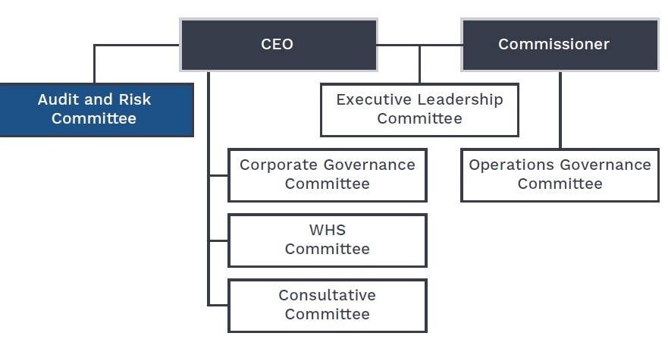

Performance

Performance measures and targets
The Commission has 3 key performance indicators (KPIs) for 2026–27 included in the Portfolio Budget Statements. These KPIs are linked to the Commission’s key activities. KPIs and KPI targets will be reviewed by the Commission annually over the life of this plan.
The Commission monitors its performance against reporting requirements through regular internal reporting. Reports are provided to the Corporate Governance Committee, Executive Leadership Committee and Audit and Risk Committee on a quarterly basis.
The Commission reports performance information for ACLEI legacy matters alongside results for activity commenced under the NACC Act. Additionally, in the Commission’s annual report, an Appendix provides a summary of the Commission’s overall progress in finalising all ACLEI legacy matters.
KPI 1.1 Percentage of referrals assessed within 90 days
Type of measure | Productivity
Target | 80%  Target is per financial year across the life of the plan
Changes from the previous year | The KPI methodology remains as per previous years. However, there are some changes in the supporting data due to clarification of case type inclusions.  Change: Own initiative corruption issue case types are no longer counted toward this KPI calculation. While they undergo a similar assessment process, own initiative cases are not referrals under the NACC Act but rather a type of corruption issue as per ss 40(1)(b) and 40(2). Own initiative corruption issues are identified through the course of the NACC’s own activities.

KPI 1.1

Target rationale
The target for percentage of referrals assessed within 90 days remains appropriate and commensurate with resources.
While the Commission exceeded the target in 2024–25, it was not met in 2025–26 due to resourcing constraints and a focus on finalising the backlog of matters received in 2023–24 and 2024–25. Over the 4 years of this plan, an 80% target remains appropriate and achievable once backlogs and resourcing have stabilised.
As the Commission commences its fourth year of operation, this approach provides a stable and repeatable figure and supports year-on-year comparison as processes mature. This will then allow the Commission to reassess this target to ensure it is realistic for future years and determine whether updating this KPI or creating new KPIs on referral assessment timeframes should be considered.

How this measure achieves the Commission’s purpose (strengths and limitations)
This measure tracks productivity under Key Activity 2: receiving and assessing referrals of alleged corrupt conduct.
In line with the Commission’s purpose, this measure aims to ensure the Commission efficiently actions referrals and, where appropriate, progresses these to investigation in a timely manner.
The methodology for KPI 1.1 allows for analysis specific to each reporting period as required by the Commonwealth Performance Framework. However, the Commission acknowledges the limitations of the KPI as it is currently described, specifically in relation to referrals that remain open beyond the 90-day target timeframe. This is why details on the open referral caseload are included alongside the KPI results published in the Commission’s Annual Report and in the analysis of performance.

Methodology
The result is calculated by taking the number of referral assessments finalised in the reporting period where the assessment duration is less than 90 days from the date of receipt as a percentage of the total number of referral assessments finalised in the reporting period.
A referral is information received by the Commission under ss 32, 33, 34 or 35 of the NACC Act. This includes:
- Voluntary referrals: anyone may refer a corruption issue or provide information about a corruption issue to the Commission (s 32). The Commission differentiates between 2 categories of voluntary referral:
- Voluntary public report: voluntary referrals received from the public
- Voluntary Commonwealth agency: referrals from Commonwealth agencies that do not meet the criteria of mandatory referrals
- Mandatory referrals: referrals where there are mandatory obligations to report to the Commission. This includes:
- Mandatory Commonwealth agency (s 33)
- Mandatory Commonwealth intelligence agencies (s 34)
- Mandatory public interest disclosures (s 35)
Exclusions: The Commission receives enquiries which may or may not be related to existing referrals or operational activities. Enquiries are most often handled by the Commission’s Intake and Triage team but do not meet the criteria of a referral and are not counted toward the referrals total or toward KPI 1.1.
Own initiative corruption issue case types are not counted toward this KPI calculation. While they undergo a similar assessment process, own initiative cases are not referrals under the NACC Act but rather a type of corruption issue (ss 40(1)(b) and (2)). Own initiative corruption issues are identified through the course of the NACC’s own activities.
Referral assessment duration is calculated as a count of the calendar days elapsed between the date received and date finalised, for each referral logged in the Commission’s case management system. This duration covers:
- receiving and triaging the referral, including to confirm the matter falls within the Commission’s jurisdiction and whether the matter is serious or systemic
- assessment and consideration of any decisions under s 41 of the NACC Act, including any time needed to acquire further information through a preliminary investigation under s 42 of the NACC Act
- administrative closure of the matter, including outcome correspondence, where appropriate.
The date received reflects the date the Commission received the referral, which is not necessarily the same as the date created in the case management system. While the date created is automatically generated and cannot be altered, the date received can be manually adjusted if required.
The date finalised reflects the date the referral progresses to a closed status. This can only occur once all decisions and administrative activities related to the referral assessment have been completed. In certain circumstances, a referral may be re-opened in the case management system, for example, where additional information is received and an outcome is considered further, or where a request for review has been received. Case re-openings are not taken into account for the purposes of calculating the KPI. The first closure date is taken to be the date finalised.

Data sources
The Commission manages all referrals received and assessed through its case management system. Referral data is extracted from the case management system to calculate results for KPI 1.1.
KPI 1.2 Percentage of investigations finalised within 2 years
Type of measure | Effectiveness
Target | 60%  Target is per financial year across the life of the plan
Changes from the previous year | Nil.

KPI 1.2

Target rationale
The target for investigations finalised within 2 years remains appropriate and commensurate with resources.
The KPI target timeframe of 2 years assumes that there will be investigations of varying durations on foot in any reporting period. The duration of an investigation can be influenced by many factors including:
- Complexity: Corruption usually happens in secret with intricate layers of deception. It takes time and care to uncover information and context around allegations
- Legal processes: The Commission has extensive investigatory powers, but their exercise is dependent on strict compliance with legal procedures and processes. Many of them appropriately require the Commission to obtain warrants from courts, and this process takes time.
- Evidence analysis: Investigations often collect very large volumes of documents and information. It takes time and effort to review and analyse this information and extract what is relevant and important. It also takes time to arrange and conduct hearings, which includes accommodating the needs of witnesses.
- Thorough and careful investigation: The Commission is committed to ensuring it makes correct and fair decisions. Rushing an investigation risks overlooking relevant information, procedural errors and unfairness
- Procedural fairness process: As part of finalising any investigation where adverse findings are contemplated, the Commission must ensure affected individuals or agencies are given a reasonable opportunity to respond.
- Court proceedings: Sometimes, if court proceedings are commenced against a person of interest while an investigation is on foot, it may be inappropriate to finalise the investigation, or to publish a report, until those proceedings are concluded, as publishing a report may jeopardise the fairness of the court proceedings.
The Commission exceeded the target in previous reporting periods because it was either not possible for the KPI to be missed or highly skewed toward meeting the KPI as not enough time had elapsed from the commencement of the Commission for it to be likely that the Commission would miss the target. The 2025–26 financial year was the first reporting period where it was possible for an investigation to have a duration longer than 2 years.
Over the 4 years of this plan, a 60% target is an appropriate target because it reflects that while many investigations can be resolved within a 2-year timeframe, more complex investigations are likely to take more time. The Commission will consider whether this target needs adjustment as more of the investigations reach resolution over the coming 4 years.

How this measure achieves the Commission’s purpose (strengths and limitations)
This measure supports Key Activity 3: conducting investigations into corruption issues that could involve serious or systemic corrupt conduct.
In line with the Commission’s purpose, this measure aims to ensure the Commission is progressing investigations in an efficient manner and supporting the Commission’s purpose to investigate serious or systemic corruption in the Australian Government. It is important for investigations to progress in a timely manner; however, this cannot occur at the expense of quality, legality or proper process. It is not realistic that every investigation will be finalised within 2 years.
This KPI calculation is limited insofar as it does not account for or incentivise the finalisation of investigations once the 2-year target timeframe has passed. However, this is addressed in the broader context of the Commission’s performance reporting. One of the requirements under s 271 of the NACC Act is to report on the status of investigations at the end of each reporting period and to provide this information by commencement year.
This KPI provides comparable year-on-year results on the timeliness of investigations finalised by the Commission during each reporting period, and allows for a comparison of factors that affect the Commission’s performance over time.

Methodology
Results are calculated by taking the number of corruption investigations finalised during the reporting period, with a duration of less than 2 years as a percentage of the total number of corruption investigations finalised during the reporting period.

Duration of a corruption investigation
The duration of a corruption investigation is a count of the calendar days elapsed between the start date of an investigation and the date finalised.
The start and end points of a corruption investigation are drawn from decision dates reflecting the formal performance of the Commissioner’s functions.
A corruption investigation begins (start date) when the Commissioner or delegate approves the investigation. A corruption investigation is finalised (date finalised) when either:
- a completion report approved by the Commissioner or delegate is provided to the Minister
- the Commissioner or delegate approves that an investigation be discontinued, for example where it becomes clear that the issue is not serious or systemic.

Data sources and key terms
The Commission manages corruption investigations in its case management system and maintains a register of investigation milestones for KPI reporting purposes.
KPI 1.3 Number of corruption prevention and education products and engagements
Type of measure | Output
Target | 100  Target is per financial year across the life of the plan
Changes from the previous year | Nil.

KPI 1.3

Target rationale
The target for corruption prevention and education products and engagements remains appropriate and commensurate with resources.
While delivery exceeded targets during the Commission’s establishment phase, performance is expected to stabilise as activities mature. Engagements will increasingly focus on coordinated thematic delivery, reflecting improved baseline capability and knowledge of the Commission’s jurisdiction. The Commission will continue to review the target for KPI 1.3 over the life of the plan and adjust if appropriate.

How this measure achieves the Commission’s purpose (strengths and limitations)
This measure supports Key Activity 5: creating and disseminating information and education to enhance the effectiveness and maturity of approaches to corruption prevention and build a strong integrity culture across the public sector.
It reflects the Commission’s commitment to providing accessible, high-quality materials and targeted engagement to its jurisdiction, including government agencies and the public. Building constructive relationships is central to achieving sustained corruption prevention and integrity uplift outcomes.
Recognising the inherent complexity in measuring behavioural and cultural change, developing a simple qualitative measure of effectiveness presents challenges. A qualitative performance measure will therefore be introduced in future years to assess the effectiveness and impact of the activities, following the completion of baseline education delivery across a substantial portion of the Commission’s jurisdiction.

Methodology
Results are calculated as the total number of products and engagements delivered during the reporting period.
Products include:
- published guidance materials, such as fact sheets, guides, e-learning modules and videos
- targeted, non-public facing correspondence addressing corruption risks and prevention strategies to agency heads and other entities
- where new content is added to an existing product or content is adapted from one format to another (e.g. a fact sheet is used as the basis for a new video product).
Exclusions: Minor updates or reformatting of existing materials.
Engagements include:
- presentations, training sessions and workshops delivered by Commission representatives
- participation in meetings, panels and events to deliver corruption prevention messages.
Note: Large events or conferences may include multiple engagements where sessions are distinct in content, presenter or preparation.
Exclusions: Routine meetings or events where the Commission does not play an active role are excluded.

Data sources
The Commission maintains a register of CPE products and engagements for KPI reporting purposes.

NACC Act reporting requirements
The NACC Act specifies reporting requirements on the performance of the Commissioner’s functions. The National Anti-Corruption Commission Regulations 2023 (NACC Regulations) provide additional detail. These requirements provide a measure of the Commission’s activity and output and are outlined in Table 2.
The Commission will publish results for these performance measures from the financial year in its Annual Report.

Changes from the previous year
In 2025–26, the Commission made 3 changes to reporting which impact results for the Commissioner’s annual report requirements compared with previous reporting periods.

Referral case types
Own initiative corruption issue case types are no longer counted toward the aggregate total of referrals received. A referral is information received by the Commission under ss 32, 33, 34 or 35 of the NACC Act. During 2025-26 it was clarified that while own initiative cases undergo a similar assessment process, they are not referrals under the NACC Act but rather a type of corruption issue as per sub-ss 40(1)(b) and 40(2).
This change does not affect any of the listed requirements directly. However, it affects the aggregate total for referrals received, which is reported alongside KPI 1.1 and Commissioner’s annual report requirements 1 and 2.

Corruption issues dealt with
In previous reporting periods, corruption issues dealt with were counted from the starting assumption that one referral was equal to one corruption issue. However, in practice one referral can include one or more corruption issues, and decisions are made and recorded against issues in the Commission’s case management system.
To facilitate more accurate reporting and to reduce manual calculation, a change was introduced during the 2025–26 reporting period. Corruption issues dealt with are now counted on a specific issue basis rather than by case. This affects Commissioner’s annual report requirements 4, 5, 6, 7, 8 and 12.
This also applies for how the Commission counts outcomes of preliminary investigations. Reporting on preliminary investigations is not mandatory, but the Commission considers it a relevant activity to include in the context of other Commissioner’s reporting requirements.

Finalised agency investigations
In previous reporting periods, an agency investigation was counted as finalised when a mandatory completion report was received, or the corruption issue was reconsidered under s 41(5). In 2025–26, the Commission revised the definition for when an agency investigation is considered finalised to more accurately reflect how the Commission manages agency investigations. An agency investigation is considered finalised:
- after a mandatory completion report has been received, reviewed by the Commissioner or delegate, and a decision on whether any further action is required has been taken, or
- when the Commissioner or delegate reconsiders all corruption issues associated with the agency investigation under s41(5).
This change has been retrospectively applied to agency investigations finalised in previous reporting periods. There is a minor impact on previously reported figures for status of agency investigations and which reporting period a finalisation occurred in. This impacts requirement 11 and is also addressed in the 2025–26 annual report.
Table 2: NACC Act reporting requirements
No. | Requirement | Legislative reference
1 | Number of voluntary referrals received | NACC Act: s 271(2)(a)(i)  NACC Regulations: s 27(a)
2 | Number of mandatory referrals received | NACC Act: s 271(2)(a)(i)  NACC Regulations: s 27(b)
3 | Total number of corruption issues dealt with (decisions under sub-ss 41(1) and 41(6)) | NACC Act: s 271(2)(a)(ii)  NACC Regulations: s 28(1)
4 | Number of corruption issues investigated by the Commission (decisions under s 41(1)(a)) | NACC Act: s 271(2)(a)(ii)  NACC Regulations: s 28(2)(a)
5 | Number of corruption issues investigated jointly by the Commission and a Commonwealth agency or a state or territory government entity (decisions under s 41(1)(b)) | NACC Act: s 271(2)(a)(ii)  NACC Regulations: s 28(2)(b)
6 | Number of corruption issues referred to a Commonwealth agency for investigation (decisions under s 41(1)(c)) | NACC Act: s 271(2)(a)(ii)  NACC Regulations: s 28(2)(c)
7 | Number of corruption Issues referred to a Commonwealth agency or a state or territory government entity for consideration (decisions under s 41(1)(d)) | NACC Act: s 271(2)(a)(ii)  NACC Regulations: s 28(2)(d)
8 | Number of corruption issues where the decision is to take no action (decisions under s 41(6)) | NACC Act: s 271(2)(a)(ii)  NACC Regulations: s 28(2)(e)
9 | Number of s 41(2) investigations completed | NACC Act: s 271(2)(a)(iii)  NACC Regulations: s 29(a)
10 | Number of s 41(2) investigations ongoing at the end of the reporting period (including any commenced prior to the reporting period) | NACC Act: s 271(2)(a)(iii)  NACC Regulations: s 29(b)
11 | Number of corruption issues referred to a Commonwealth agency for investigation (decisions under s 41(1)(c)), that were referred, investigated and completed during the reporting period | NACC Act: s 271(2)(a)(iv)  NACC Regulations: s 30(a)
12 | Number of corruption issues referred to a Commonwealth agency for investigation (decisions under s 41(1)(c)) where there is oversight by the Commissioner | NACC Act: s 271(2)(a)(iv)  NACC Regulations: s 30(b)
13 | Number of public inquiries completed | NACC Act: s 271(2)(a)(v)  NACC Regulations: s 31(1)(a)
14 | Number of public inquiries ongoing at the end of the reporting period (including any commenced prior to the reporting period) | NACC Act: s 271(2)(a)(v)  NACC Regulations: s 31(1)(b)
15 | Number of s 235 certificates issued by the Attorney-General | NACC Act: s 271(2)(a)(vi)  NACC Regulations: s 32(1)
16 | Number of s 236 (international relations) certificates issued by the Attorney-General | NACC Act: s 271(2)(a)(vii)  NACC Regulations: s 32(2)
17 | Extent to which corruption investigations have resulted in prosecution of persons for offences | NACC Act: s 271(2)(e)
18 | Extent to which corruption investigations have resulted in confiscation proceedings | NACC Act: s 271(2)(f)
19 | Number and type of applications made for judicial review | NACC Act: s 271(2)(g)(i)
20 | Outcomes of applications made for judicial review | NACC Act: s 271(2)(g)(i)
21 | Number of other court proceedings involving the Commissioner | NACC Act: s 271(2)(g)(ii)
22 | Outcomes of other court proceedings involving the Commissioner | NACC Act: s 271(2)(g)(ii)
23 | A description of the kinds of corruption risks, corruption vulnerabilities or measures to prevent corruption into which the public inquiry or inquiries were conducted | NACC Act: s 271(2)(a)(v)  NACC Regulations: s 31(2)
24 | A description of the corruption investigations conducted by the Commissioner during that year that the Commissioner considers raise significant issues for, or reflect developments in, Commonwealth agencies | NACC Act: s 271(2)(b)
25 | A description of any patterns or trends, and the nature and scope of corruption in Commonwealth agencies or by public officials that have come to the Commissioner’s attention during that year | NACC Act: s 271(2)(c)
26 | Any recommendations for changes to the laws of the Commonwealth or administrative practices of Commonwealth agencies that the Commissioner, as a result of performing the Commissioner’s functions during that year, considers should be made | NACC Act: s 271(2)(d)

nacc.gov.au

